Maria’s conference transcript from the 2013 Annual Ritual Abuse, Secretive Organizations and Mind Control Conference: R&R (rest and relaxation)

Until age seven Maria was subject to satanic abuse. Maria experienced perverse worship, torturous brain programming, sexual violence, body dislocations and was drugged. Although relocated at age seven; molestation from random strangers and family members continued until she moved out. Since she was age 19 in 1991, she has been consistent in healing herself and reversing all the mind control experienced in her life. She lives well with profound awareness. She now experiences joy and peace. Her topic was: R&R (rest and relaxation)

Please use caution while read to this presentation. It may be very triggering. All accusations are alleged. The conference and this transcript are educational and not intended as therapy or treatment.

http://ritualabuse.us/smart-conference/
2013 R & R
2012 FREE AT LAST
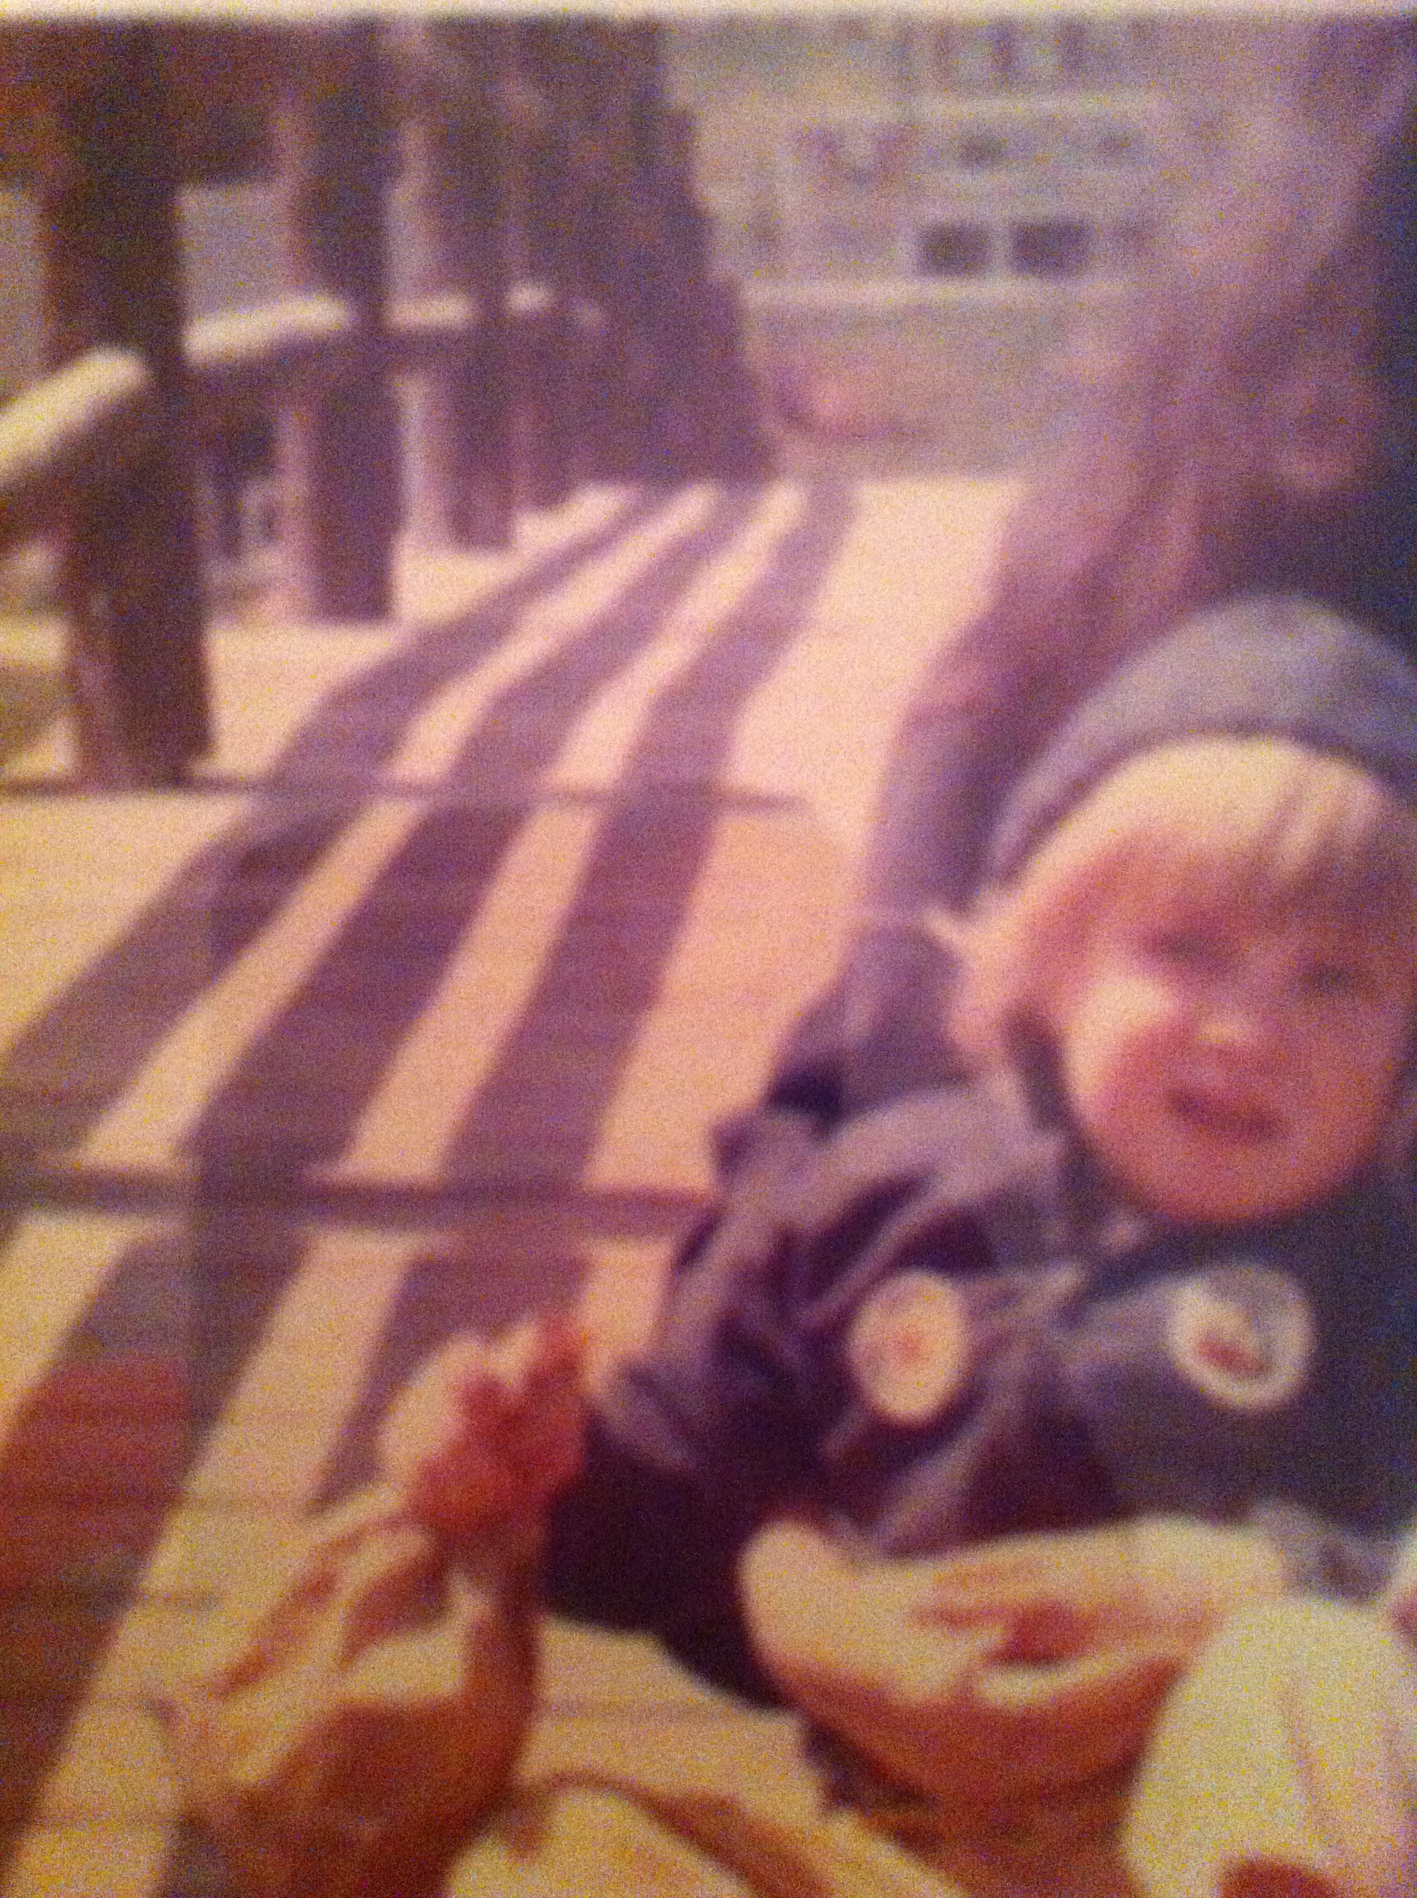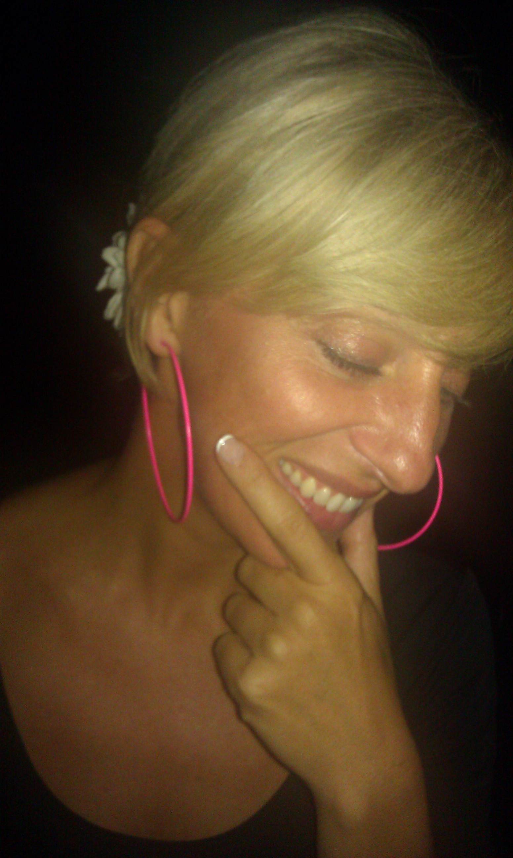
Until age seven Maria’s was subject to satanic abuse.
Maria experienced perverse worship, torturous brain programming, sexual violence, body dislocations, and was drugged.
Although relocated at age seven; molest from random strangers and family members continued until she moved out.
She lives well with profound awareness, joy and peace.

Since she was age 19 when her flashbacks began in 1991 she has been consistent in healing herself and reversing all the mind control experienced in her life. She has used conventional talk therapy once a week for ten years as well as recovery groups (Incest Survivors Anonymous), all genre’s of Yoga (Kundalini, Hatha, Vinyasa), eating Organic foods (NO GMO), Receiving Reiki, Lymph Drain Massage, Acupuncture, Jin Chin, Cranial Sacral, Breathing Work, Bert Hellinger, Polarity Therapy. REMDR, Core Energetic, Manual Medicine, Swaying Technique, EFT And Creative Arts as therapy to heal her full self.
(Note: she chose a healing path without the use of any medications.)
INSPIRATIONAL SPEAKER - MARIA ROSE PIRONE

-To help stop future occurrences of ritual abuse
-To help survivors of ritual abuse
-To name the groups that have participated in alleged illegal activities
-To unite those working to stop ritual abuse

Photo of Maria’s Mother:
A story of how to heal and prevent this type of before and after.

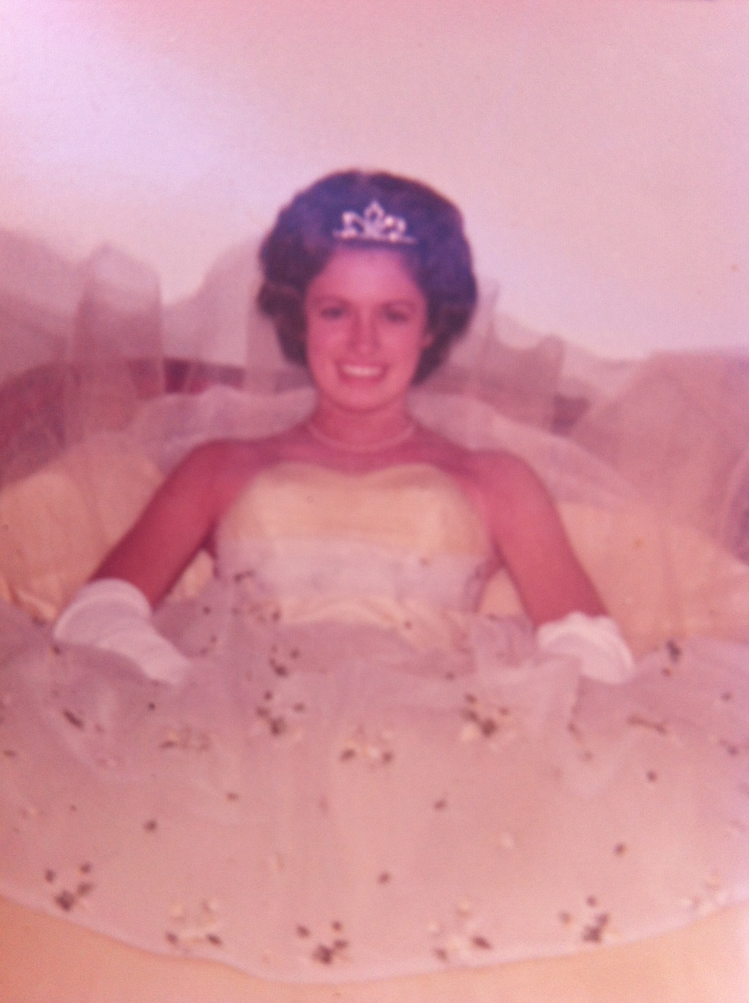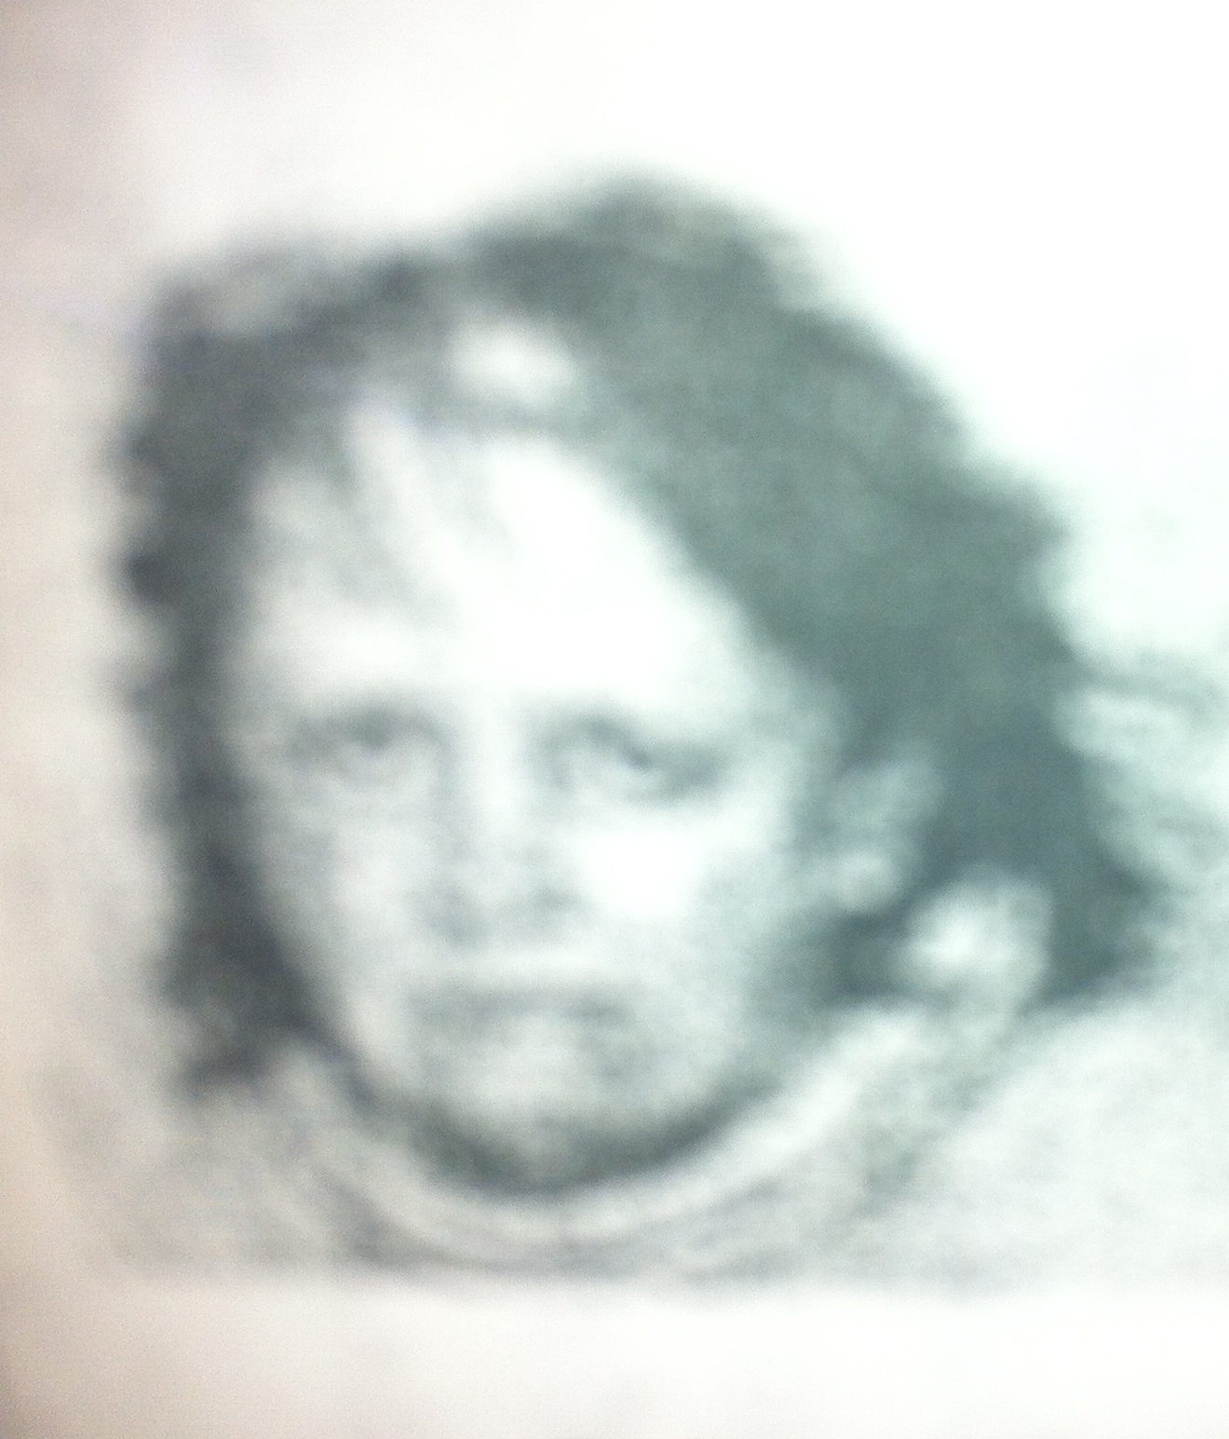
before after

Maria has several case reports that she researched through Child Protective Services and Yale Child Study Center after her remembering of her repressed childhood traumas.
Her memories emerged in her early 20’s through panic attacks dreams and during sexual intercourse with her boyfriend at the time. He suggested she look into this and heal further. So she looked further to confirm that this history she was remembering was actually true. 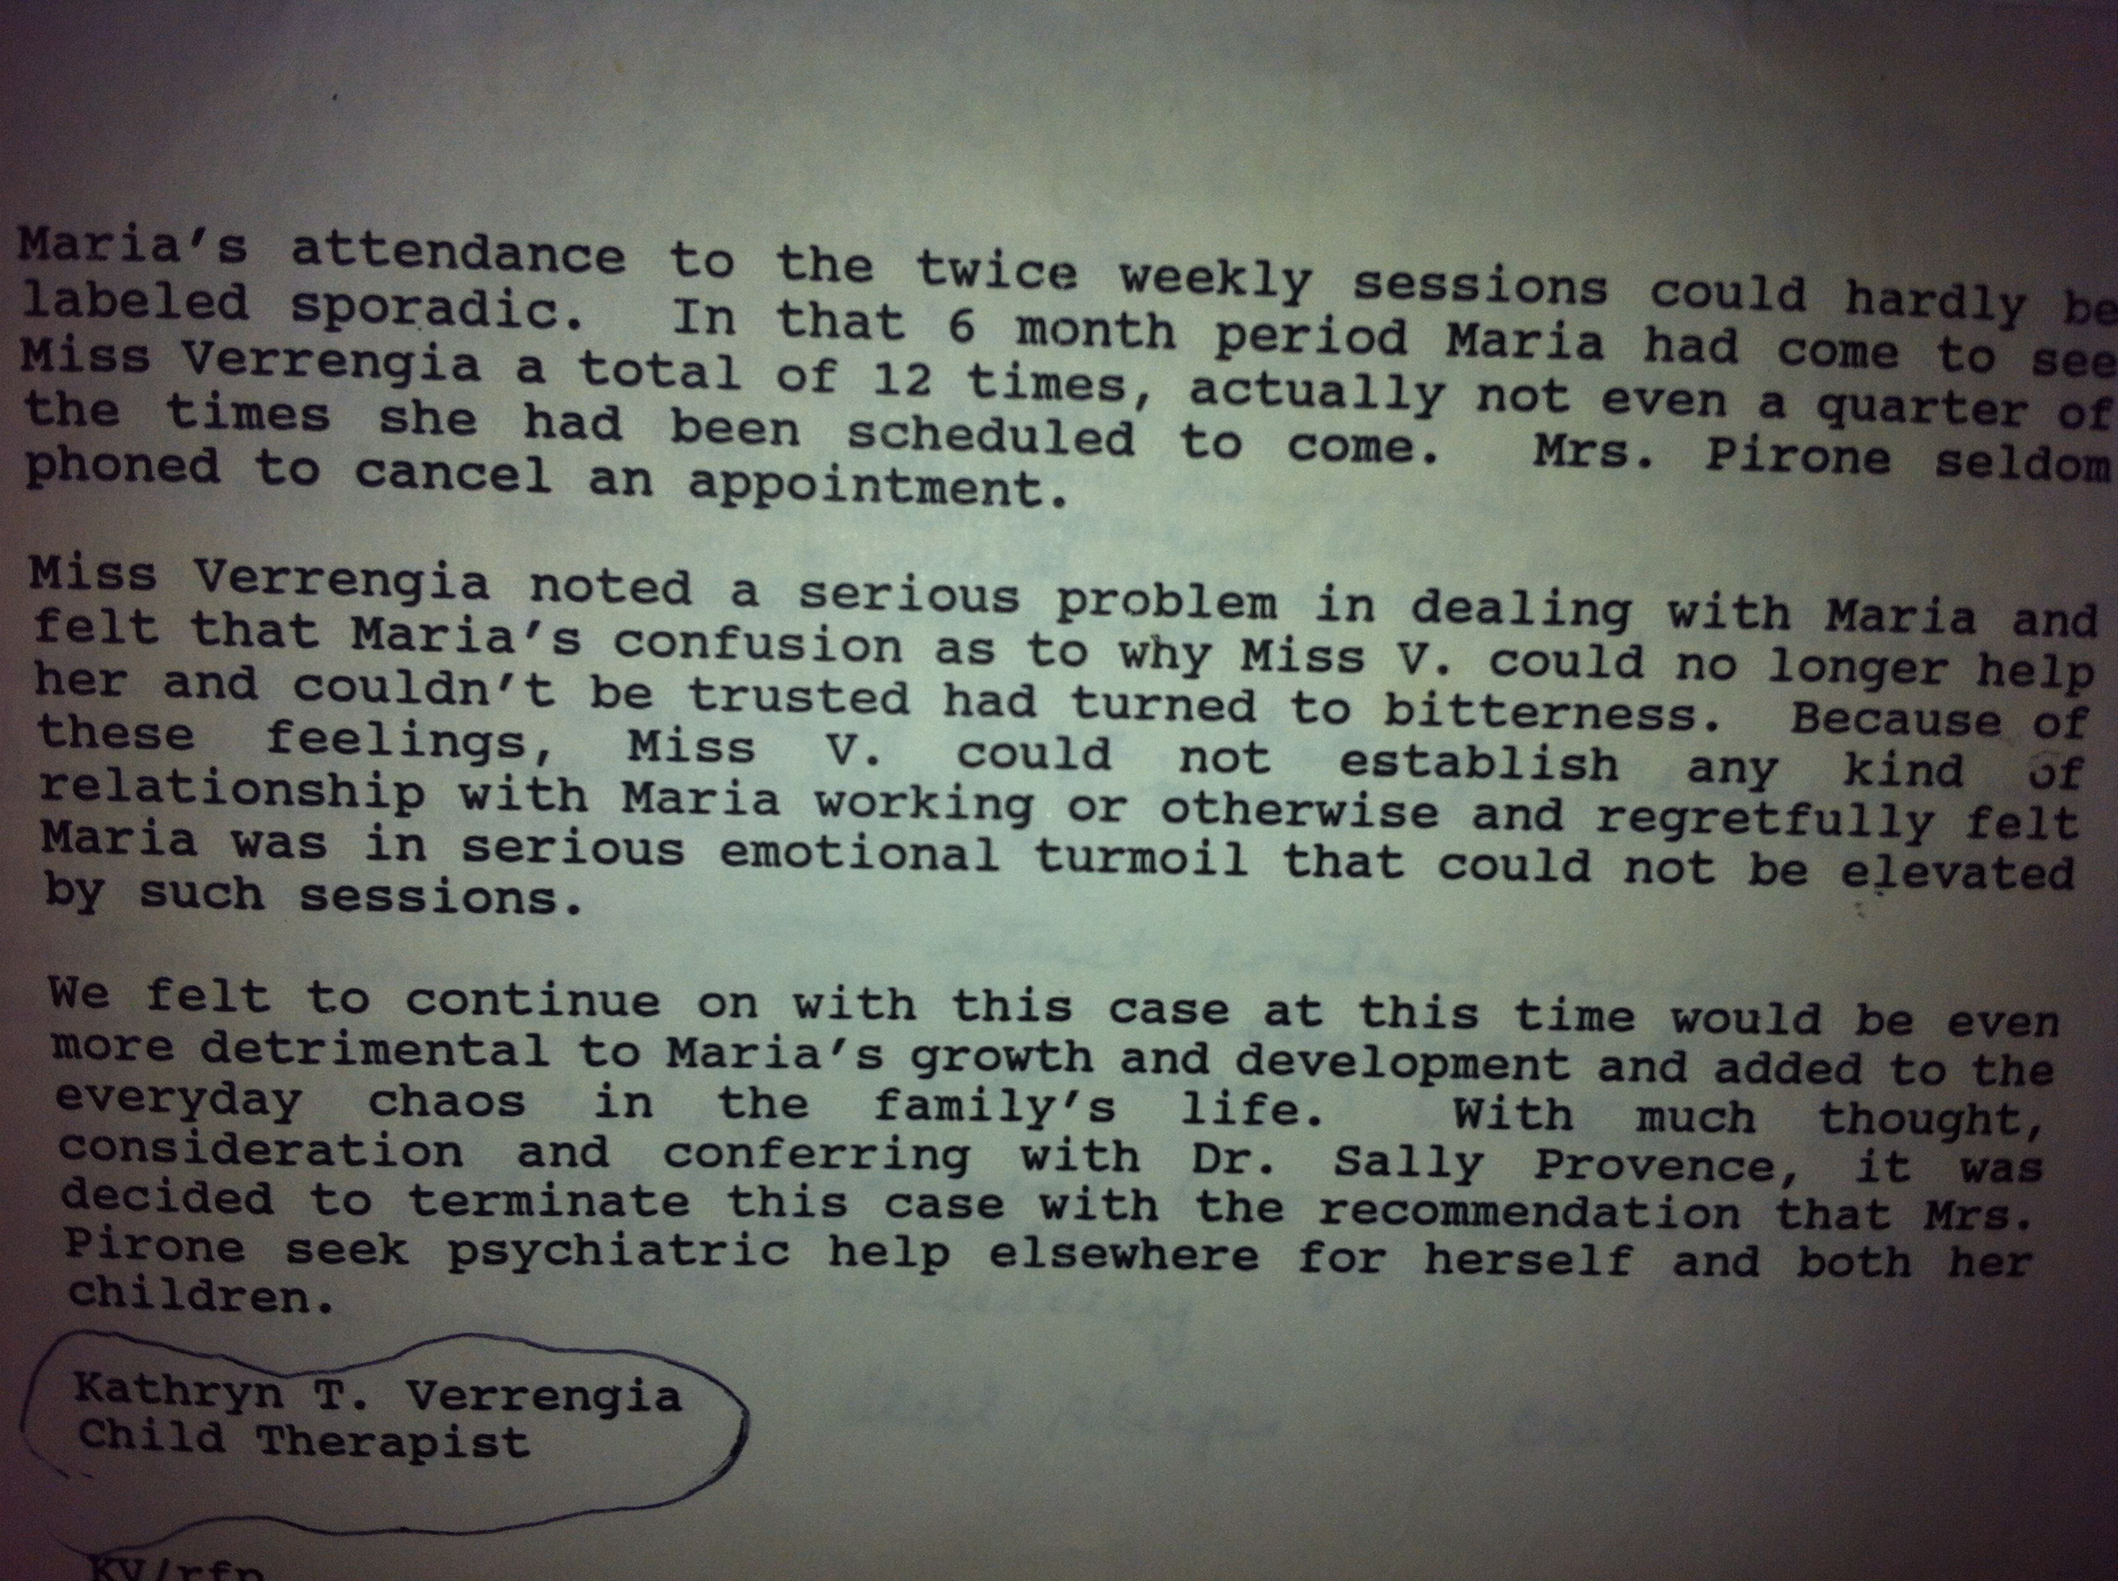

Rest and Relaxation brings Awareness.
As torture survivor I was trained to be in a constant state of hypervigilance and terror. If I am always in terror I can not heal and then I can not tell my truth and expose the cults.
It took decades for me to even scratch the surface of the words ‘rest and relaxation’. I felt ashamed to rest like I was lazy for sleeping in at times. Then the idea of taking a trip to a tropical place for relaxation hit me with guilt and I felt like it would only be ok to travel if I said, “It’s for work.”
And actually in truth it was, it took a lot of work through out my life to learn how to let go of the hypervigilance and terror that was forced in through out me daily for the first 18 years of my life.

When I began to relax I would instantly begin to panic. Feeling the existence of my own feet on the ground had me thinking some how the ocean was going crawl over the land or it might rain to hard and all waters would fill up over my body and I would drown.
“It’s ok to have my feet on the ground. It is safe to be here on earth. I am safe now. Look, Maria there is sunshine and nice people sitting in a near café…I am safe…I am sane…My name is Maria Pirone.”

I had to repeat affirmations like this until the terror subsided. Sometimes stopping to touch my feet in a crouching position and make sure I was still on the ground. The panic was so bad that I did not care if I looked like a nut job crouched down on a sidewalk to try and regain sanity. Now at times when picturing it all, I get a chuckle. What people must have assumed?
“What’s up with this lovely blonde woman in a wide eyed ball of terror whispering to herself. Oh boy…She must be nuts.”

Below is a version of one of the year’s I took a little R & R:

During winter holidays, I have for several years now chose to leave what reminds me of darkness in my family. USA holidays can be high triggers of anxiety for satanic abuse survivors.
The overall denial of sick families is doused in tinsel flickering lights hung on cut trees, and shopping madness for the seasons seduction. Loud colorful distracting holidays can make for lots and lots of quiet and unseen underground darkness.
So I take off far way to a secret tropical island. I now choose warmth, and kind authentic hugs from the heart. A place where brightness overrides the shadows. Smiles neon white from bronzed local vendors welcome families in multi-colors from around the world. Travelers’ group in cheer and some in great reprieve.

On the Island I choose a quiet hotel with mostly seniors, war vets with severe PTSD. Chuck is my hotel neighbor. He is an old war vet and the leader to the pack of his rowdy geriatric retirement buddies. I am warmed by the open speak of their trauma and their ability relax in the after math of it all.
Chuck is a small feisty man, who often rants and raves,
“Those damn dogs barking and the racket of the local clubs F-ing loud music all night.”
Some call him crotchety, but for me it was his old burdens become brittle, crumbling from the internal tremor of strained hope that cries out still for serenity. I could relate to his desire to control this oasis he found for personal peace.
For I too know of great wars and have PTSD from them.

We would meet some times on the beach. This pack of charming oldtimers would offer me a piece of fisherman’s morning catch or beer, as we all toasted to toasting ourselves in the sun. I could feel their weight of the past tragedies sweat out as the days past. At least their veteran’s pensions provided them for some months of safe restful nothing and nonsense. Hmmm, maybe some day there will be a pension for Satanic Ritual Abuse Survivors.

In between their telling of war stories and dirty jokes or betting on who can tell the exact time by the suns placement in the sky; I noticed they would give each other frequent looks, eye to eye full of connection. Their lids would rest lower as a small boyish smirk moved their leathery faces into even more cheeky wrinkles.
I too, noticed my neck lengthen out from my tensed shoulders in these moments of mutual compassion in regards to tragedy and freedom.
I listened to them share war stories. I was finally not alone in my memories of twisted torture or PTSD and the burden of being innocent then charge with guilt. Chunks of tension began to melt from my own shoulders. Although I kept quiet about my own war, I knew if I wanted to confess, these kinds of men could actually believe me.
I felt like turtle safe enough to come out of her shell for real R&R.
I could see good souls behind their salt watery eyes. I admired the wisdom in them. Surrounding crow’s feet lined their eyes like ancient maps leading to the center of their fears and surrender. At moments I swear I could hear ours minds remember and whisper in tandem..."I never wanted to be trained in hate and killing. I just wanted peace deep down."

One sunny day at dark cloud began hovering over the beach and one of the guys coughed to his buddy,
"Hey Bones, looks like the rain is coming. I remember when we were stuck for 3 months in nonstop rain and all of us had completely pruned bodies. I was not sure if my f-ing skin would ever go down again...we had nothing to eat...and No one from the military cared to find us."
Then Chuck looked over to me.
"Maria you know no one tells you this kind of stuff that really happened over there in Nam."

I sat present and thought, how amazing it can be if the world could believe and hear about satanic ritual abuse survivor stories with as much respect as they do about war stories or the Holocaust.
In honor of these brave people commemorating holidays were created as well as communities of support, pensions and scholarship funds. Where is the worldly honor for satanic ritual abuse survivors? Heck where is the belief that it even happens?

The media mystifies it with vampire dramas and lots of sexy people. The News cuts it short with quotes form naive pedestrians saying things like, “Wow I never knew that went on next door… I mean they were such nice neighbors and I heard their kids got straight A’s”. Child protective service and therapists are rarely trained to identify the signs. And I dare to say portions of the government and police force are often involved with the very perpetrations they pretend to stop, like underground cults and or child sex/torture rings.

I do dare to say this because I was there, living in it as a child. A place and time when my mother could drop to her knees and sexually service an officer out of her own crimes. A time and place when, Men in suits came to purchase the most attractive child for pornography shoots held in the basement of a local bar. Or when medical and prison equipment was discretely delivered to the farms and re-rigged for uses of mind control torture machines.

I can only imagine the day when I am about to go out with co-workers or friends and able to say casually, "No thanks, I can not eat sushi today. The texture sometimes reminds me of having to eat human flesh as a little girl in a satanic ritual."

The vets had to drink rainwater to survive–while I had to drink my own urine to survive. They were trapped in the jungles alone. I was trapped in a meat freezer, an oven, and dingy basement torture chambers alone. The vets had pruned skin to the extreme. I had welts cuts and punctures throughout my vagina to the extreme.
This is not to compare the two…but rather just to display an honest example of my war fought and freed from; but yet a war that still goes on for billions of children today.
Current statistics show that over 2000 children in the United States are reported missing per day. Again, per day over 2000 children in the United States are reported missing. Cults are skilled kidnappers. I watched them do it as a child. I call it the drive by syringe.

Little did these vets know while looking at my sun tanned skin and kind smile - that I know, like they do about the smell and colors of maimed bodies and the horrid unfairness of having to abide by a twisted authority.
I was physically tortured, brainwashed, drugged and beaten into an almost mold of what the cults intended. I saw murder in satanic sacrificial rituals and was forced to partake in murder.
And I was a child through it all.

My only will to survive lived far away in the future in hopes to tattle tail. Tattle tail so loud it shatters the continued denial and re-shapes our world into a safe place for children to be seen, loved, and taken seriously.

It humors me to know these old veterans on the beach packed with PTSD found a reprieve in my company. This is what happens when one chooses to heal and is graced with finding real support.
Lets make the support stronger- bigger and gentle. I am here as an example of being FREE AT LAST.

I am so grateful for this opportunity to share some of my story and to say this satanic stuff is as big as the Holocaust, Nam, and all wars present and past.
I use my voice for others to have a voice. I use my experience of trauma then recovery and into the present joy, to prevent further trauma. My healing and bravery to promote healing and bravery.

I have soulfully reviewed history and see clearly that the fighting against anything really does not do too much. Again, I have soulfully reviewed history and see clearly that the fighting against anything really does not do too much.
Violence causes more violence- so we can fight like they do in politics by using war, but this method fails still because holocausts, wars, and especially satanic ritual abuse has continued with in the basements-barns-universities-preschools-churches-dance clubs-and anywhere around the world.

I soulfully believe that the strongest way to ‘fight’ against sadistic ritual abuse is for Every Survivor to Heal.

The facts, feelings, and healing.
Prior to my birth, my mother was in her mid twenties and married her psychiatrist. He was nearing his 60’s when they married. Shortly into the marriage he deteriorated for at least 6 months into death. It is said and I am not 100% on this, that according to my father’s side of family he died from hypertension disorder. And according to my mother’s side of the family it was Brights disease.
I do know my mother was pregnant with me while at his hospital bedside almost daily for the length of his deterioration and termination out of this life.

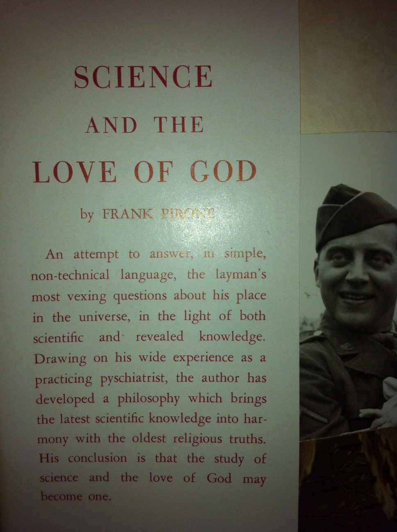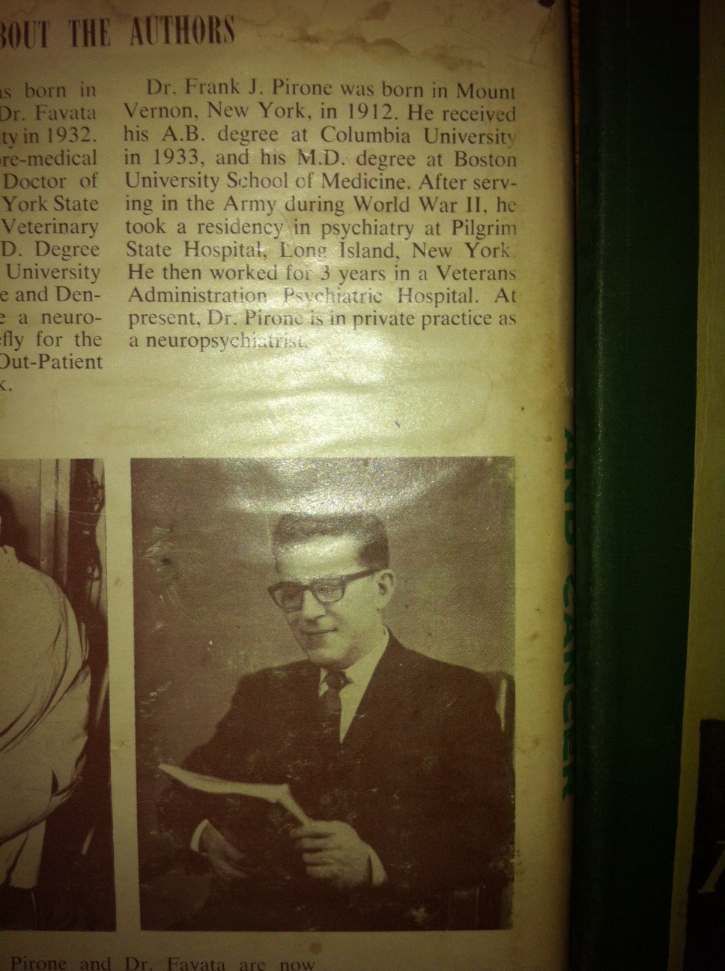
These are photos of my father’s books written and some of his text. He was a real smarty-pants…
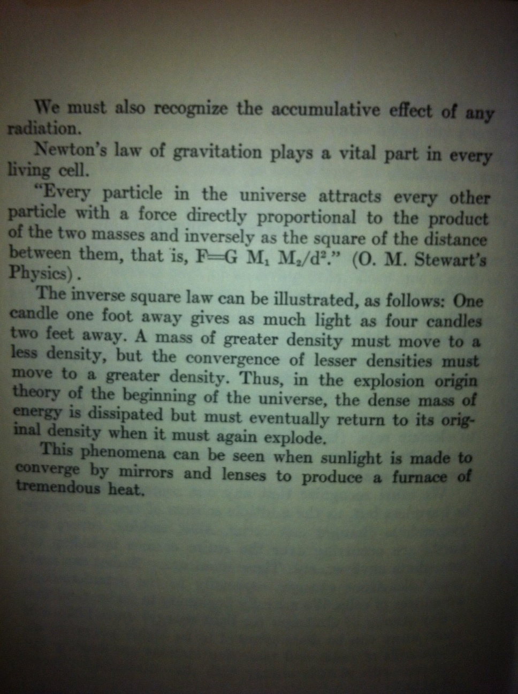
In Connecticut near Yale University and other spots on east coast my mother raised me until age seven. The majority was lived in Connecticut of those years. I was subject to a satanic ritual abuse cult that I believe was in affiliation with Skull and Cross Bones of Yale University.
The satanic cult was introduced to my Mother by her boyfriend. He was in my life from my age of 2-8. There is a possibility was my mother’s boyfriend even before she met my father who was her psychiatrist.
His family was involved with the cult. And I was sent there often with my mother and brother at times. Yet, I was mostly alone.
It was a trashy farm house, but I remember fancy places as well like Yale hallways and dungeons, pretty county homes and giant warehouses with large freezer rooms and ceilings full of hooks and/or big cattle barns, dingy basements with swimming pool looking areas full of smelly dead bodies that they burned up.
The cult often hung bodies from things during torture. They would rope me at my ankles and hands then hang me from barn rafters. Poking me with hot branding tools, whipping me and ejaculating in and on me while calling me things like ‘little lamb for Jesus’. In the cult both Jesus and Satan are one in the same. It was taught that there is no Jesus. Only Satan.

These people were and are nuts, still to this day when I look back at me going through this…. I am amazed I survived and even then as a child had a sense that this crap they were feeding me was not congruent with the beauty I some how naturally connected to. Like when a little ladybug landed on a flower. Or when Snoopy would dance and sing on top of his doghouse with Woodstock in a Charlie brown cartoon. There had to be good out there, had to be good some where in the world.
So I held on…through it all.

These are files I retrieved regarding police reports CPS and psychiatric notes from Yale Child Study Center. My coping behaviors in order to deal with the trauma were at first diagnosed as autistic. But in actuality the satanic programming reversed my motor skill ability. This is part of the cults programming mind control in effort to make me feel inept, unless I was doing a task for the cult.

There is so much intricate torture-therefore the healing must be as intricate.
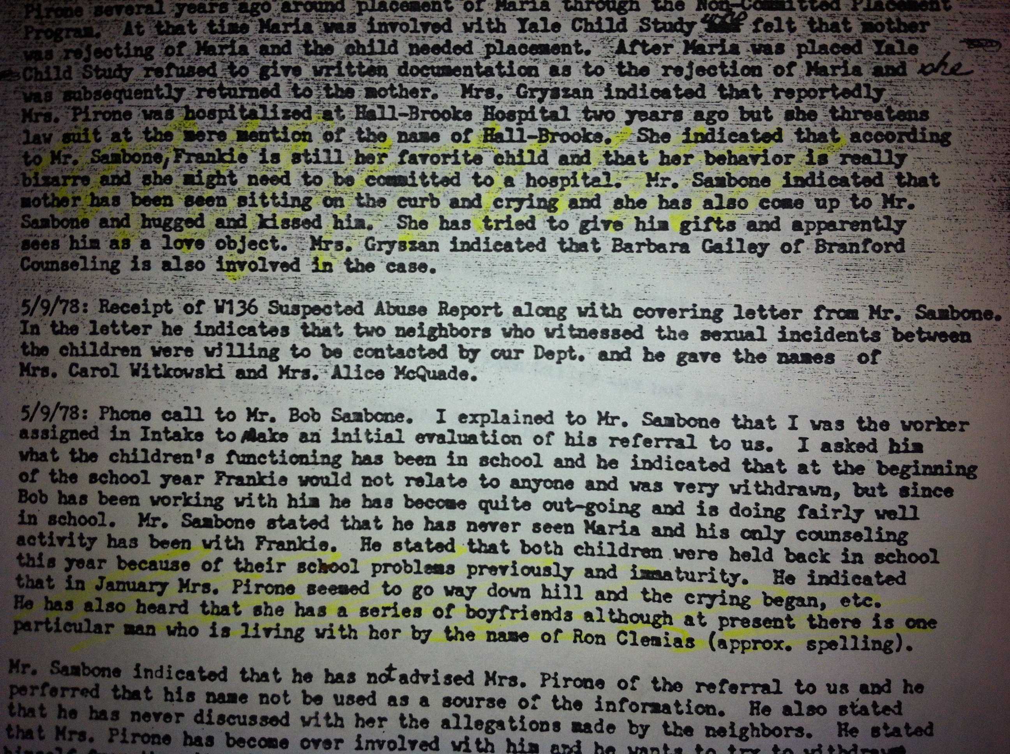

Also, I do believe judging from dysfunctions of my mother’s immediate family and do to loss of my father her already unstable character escalated upon my birth.
The cult trained my mother to believe I was the spawn of Satan and my life force took the life away from my father. She was trained to be wary of me because I was said to be a shape shifter and could fool her. In her eyes I was the farthest from a little girl.
I was a normal loveable little girl.
This is me with my lucky brown bag.
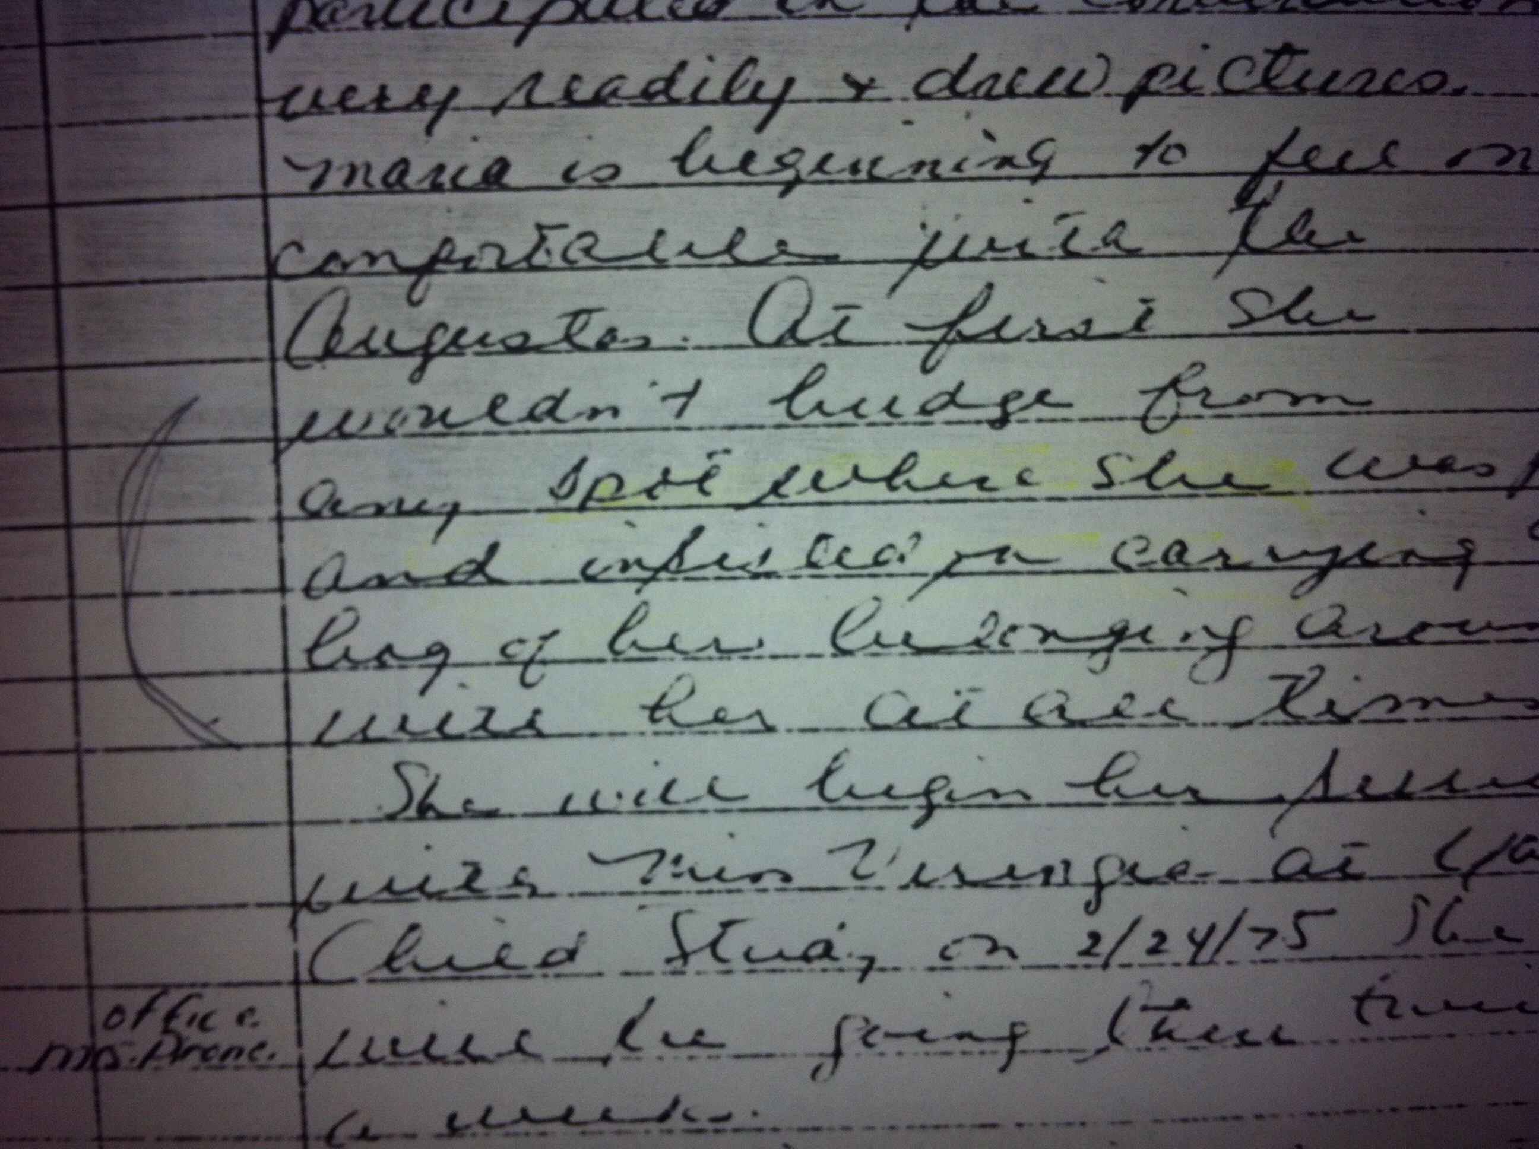
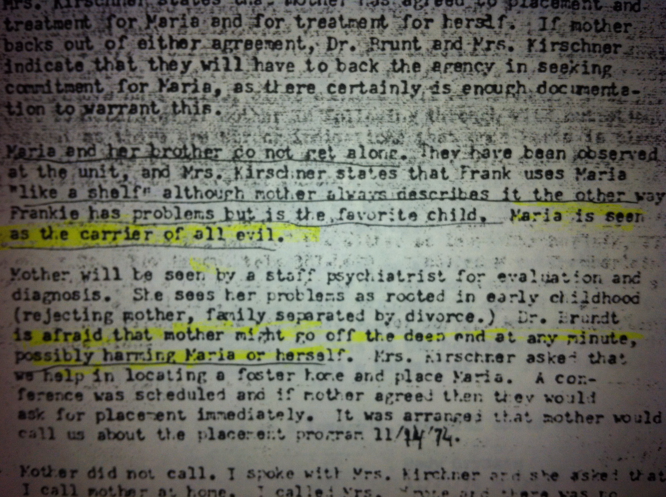
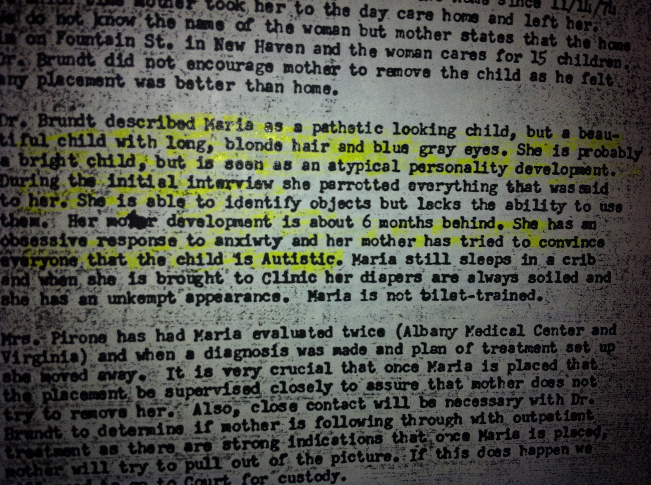

I had 1 living brother, 1-year-older, Frank.
Named after my father.
As an extremely wounded widow, and survivor of god knows what herself; my mother had transferred her husband longings onto Frank and he slowly lost his sanity over the years. I watched him grow rage full distant and more confused by her incestuously smothering attention on him.
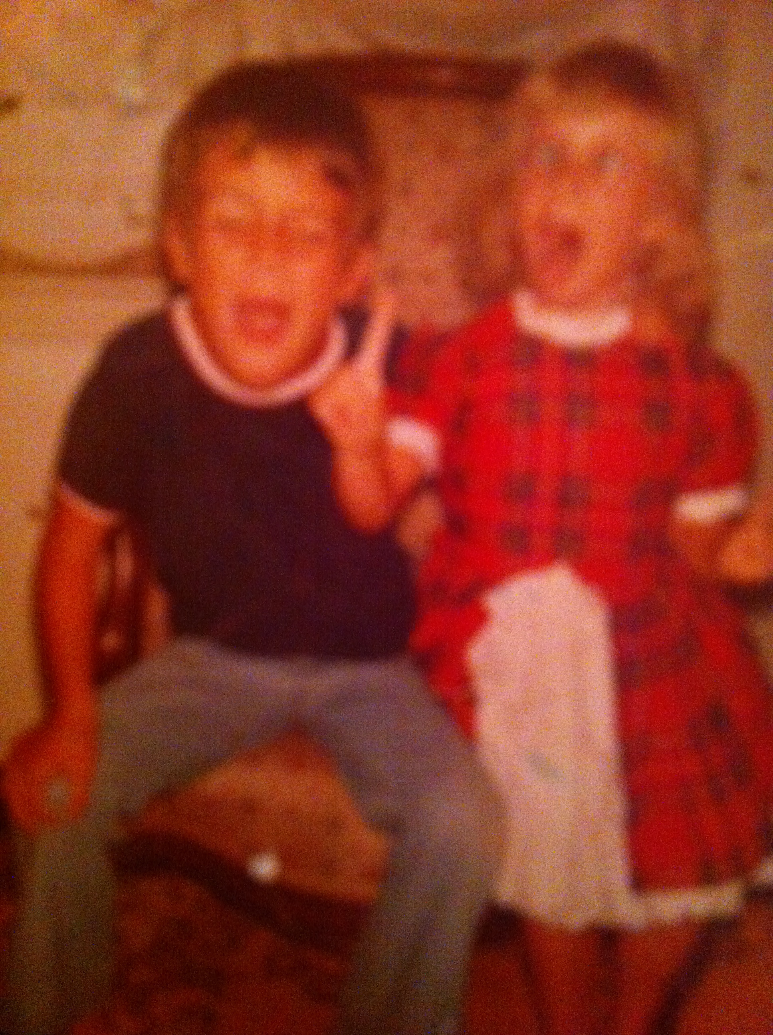

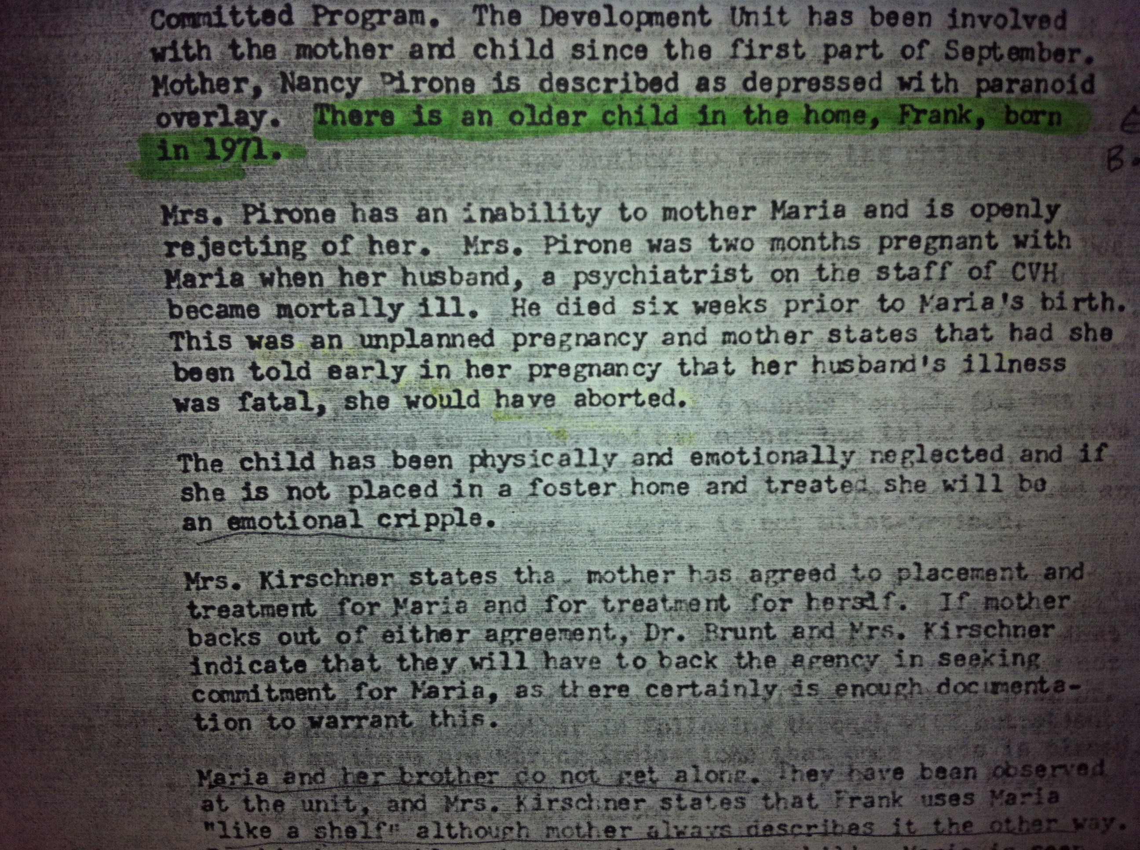
Over the years I believe my mother at home ritually molested my brother by having him orally please her and French kiss…etc. After our grandmother got custody of us around 1978 he suffered in rage fits that became worse and worse. This is a photo of Frank in late 1980’s prior to his passing. I watched his self hate and pain take over his spirit year after year, Banging his head, spitting, and kicking at things-‘for no reason at all.’ Unfortunately, he began raping me after I hit puberty; I repressed it along the way and turned my turmoil into self-mutilation and sexual acting out.
His violence escalated until he died in an explosive car crash. I assume it was suicide. He often went into rage fits while driving and crashed into things. Some times I dare to wonder if he may have been programmed by the cult to die by his age of 19.
An odd thing I will always remember was he always said, “Maria by the time you turn 18 you will no longer be hurt anymore.”
I never understood what he meant, until the night his death was reported. It was the quietest night of my life, much like silence in NYC after 911. But this loss of Frank was not sad for me, in fact I felt a freedom that had others assume I was in shock from the loss.
Somewhere inside I must have known he could not rape me any more.
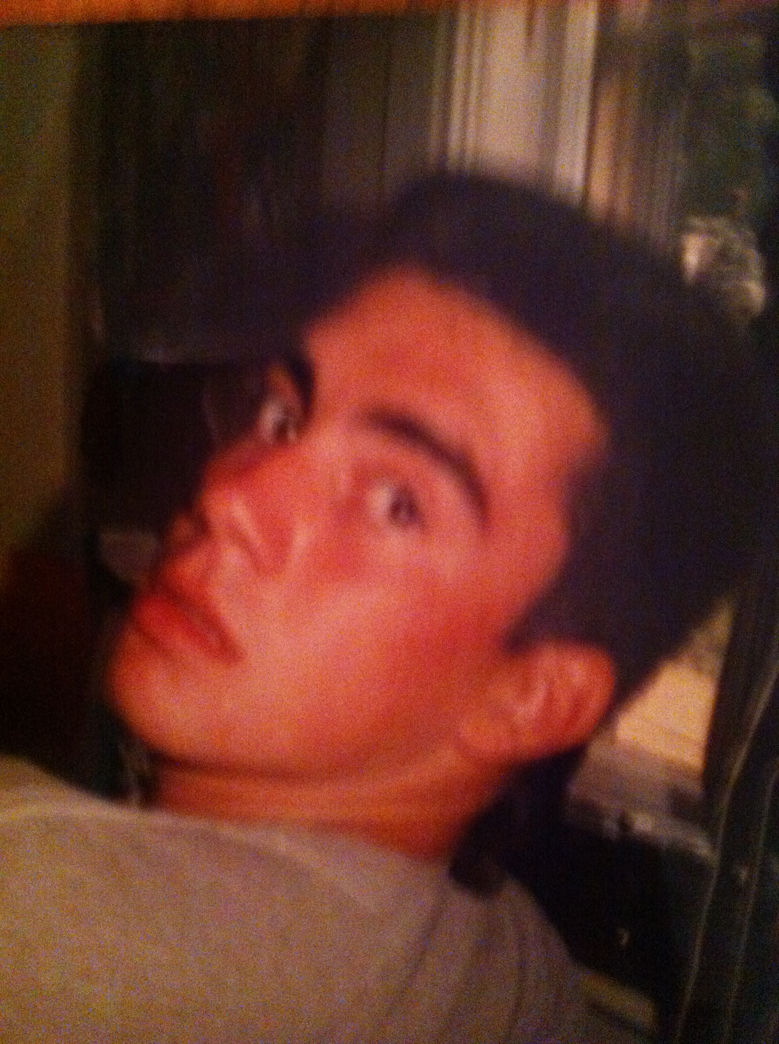
Violent acts towards the self and others are always unnatural and
always are learned behavior.

All acts of violence are symptomatic responses to trauma unresolved.
I am a firm believer that no one is born evil, but rather becomes it through experiences of trauma and possible weaker DNA, which leaves them unable to decipher negative influence from self purity and goodness.

Acts of natural ‘self-defense’ are not usually based in a pre-conceived desire to be violent, nor kill. Self defense is based in an act of self care and or care for another.

Frank was once a child subject to severe traumas and daily incest from our mother. I believe the reason he began raping me when I hit puberty was his response in terror of me becoming a woman like our mother or just the mere physical resemblances triggered him. I became his target for him to regain some sense of control over what our mother had done.

My Mother when she was young. I assume this photo was prior to her cult affiliations.

My Mother about 35 years later.
After a life of severity toward herself and her children Frank and I.

before
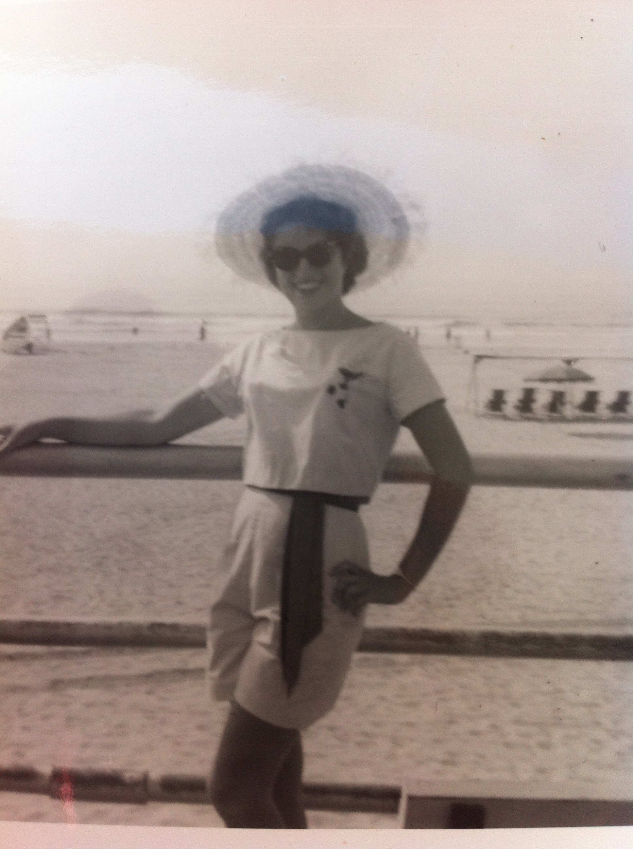

after
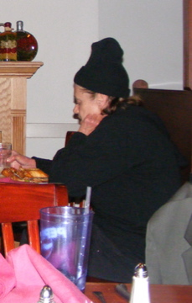

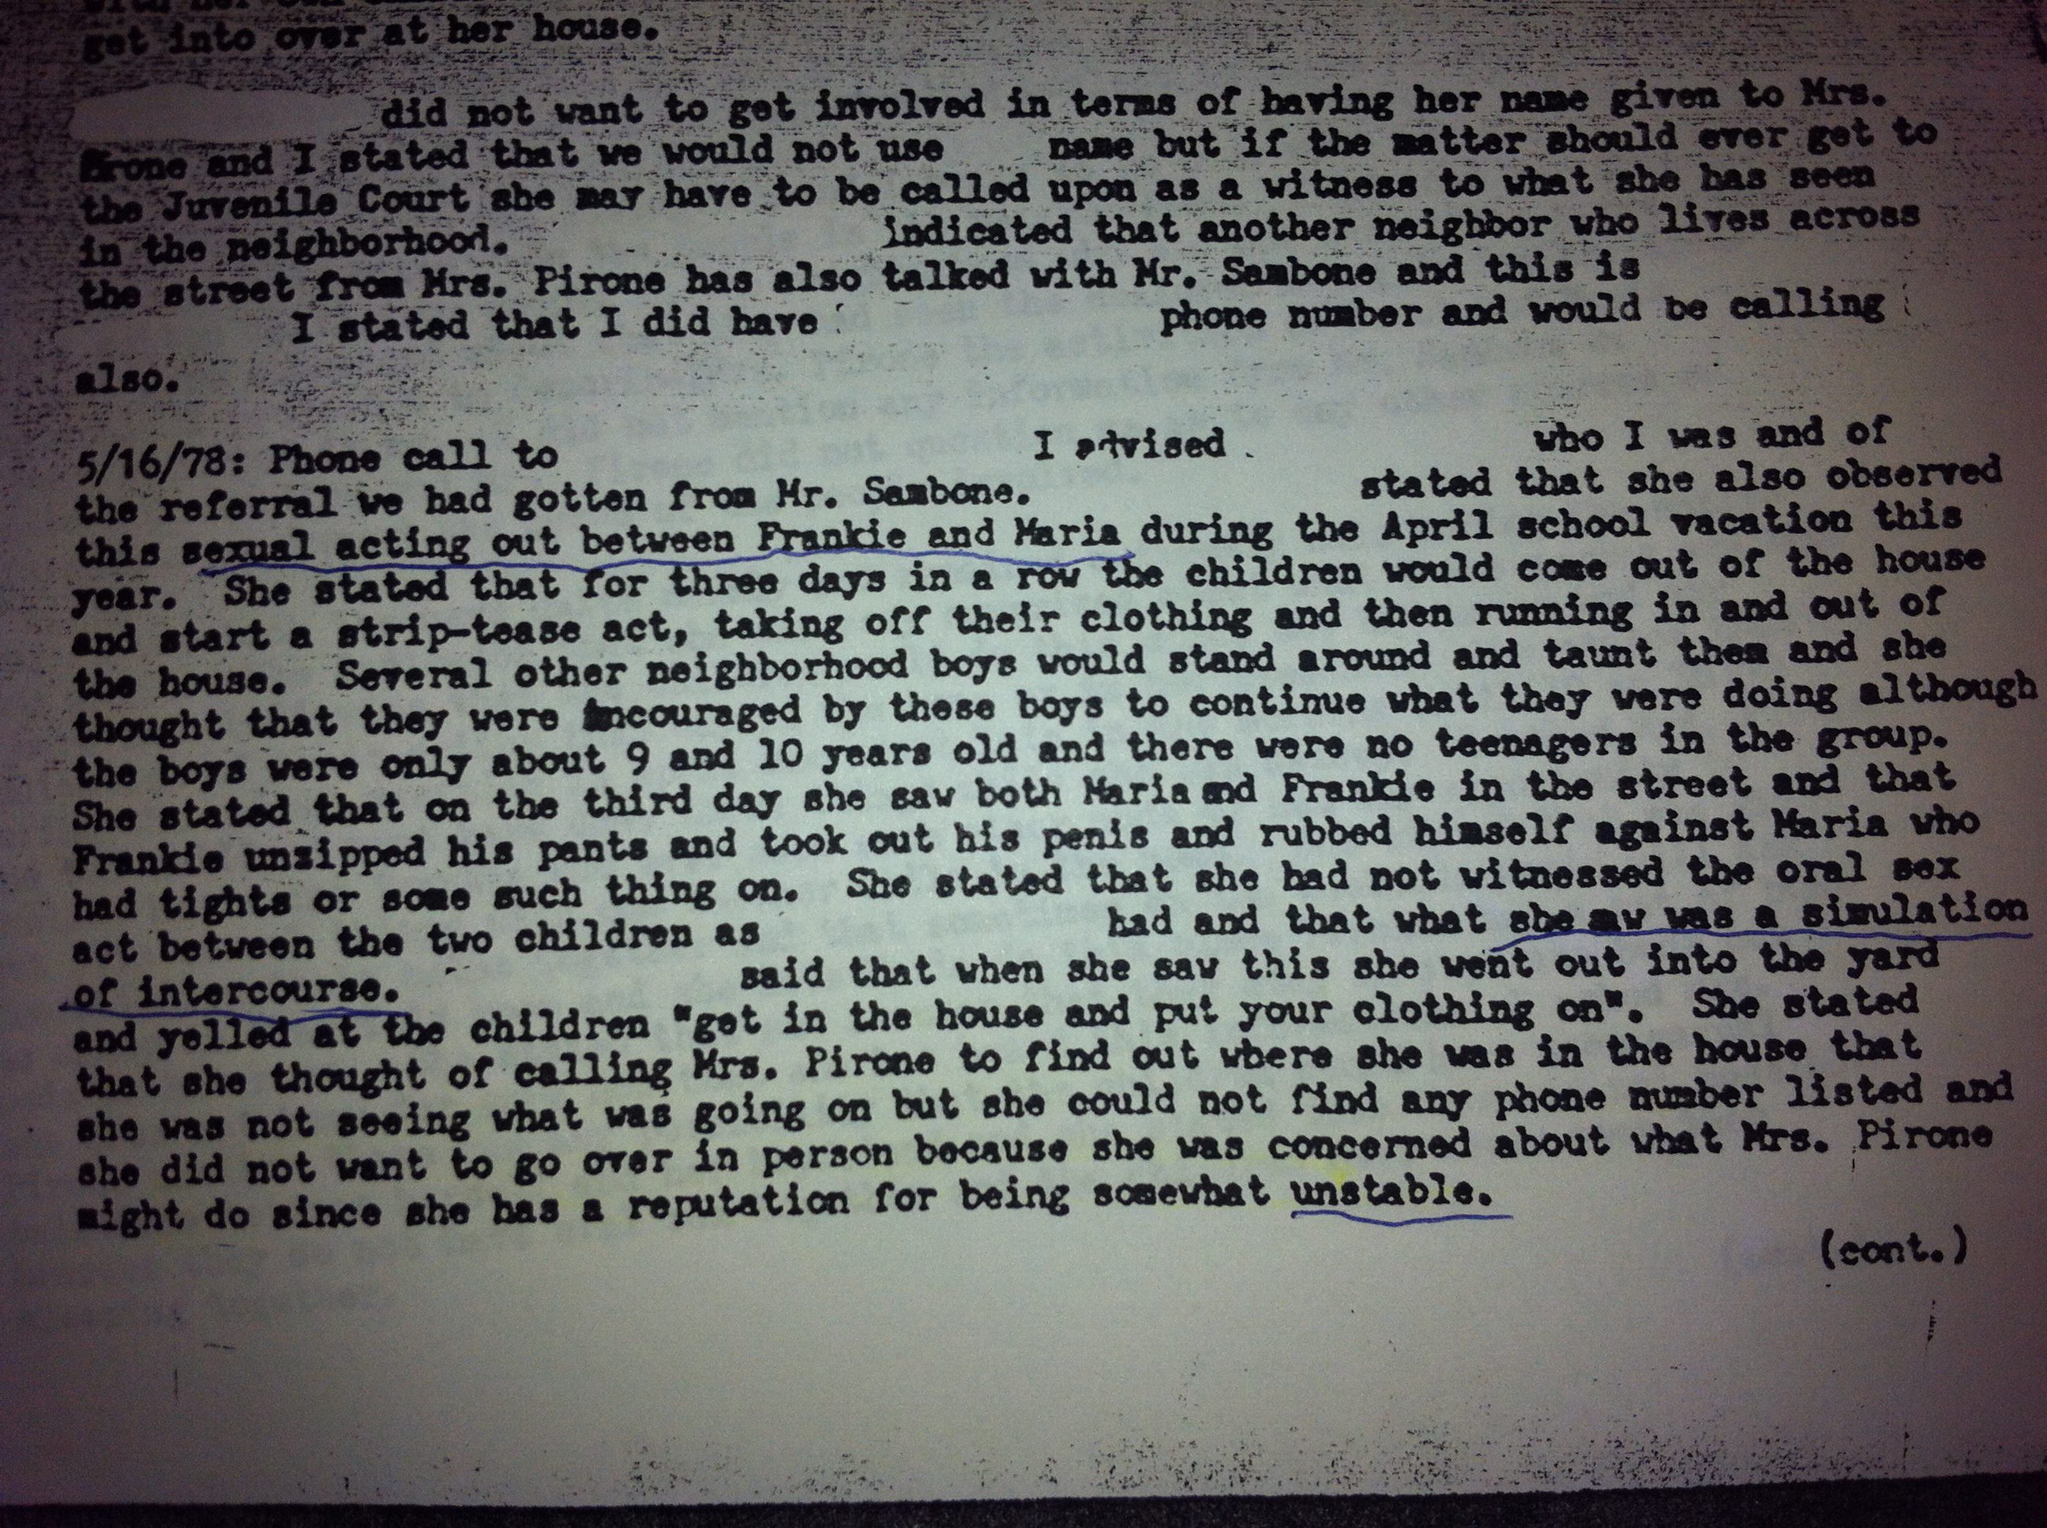

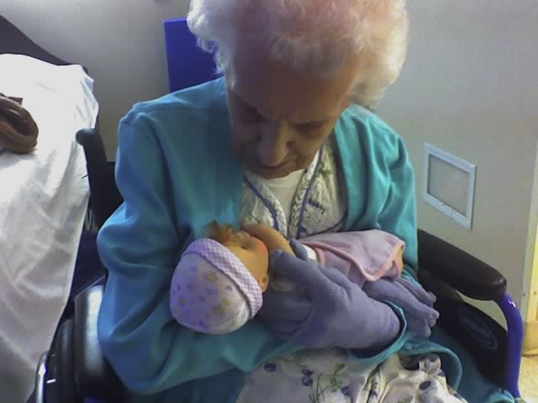
Gram- took custody of frank and I. This is photo of her last days in the nursing home. Some ‘parents’ mean well in their effort to care for a child. Gram for example gave us food, shelter, clothes and basic education, but unless any parent or fostering caregiver acknowledges their own possible traumas and heals they are destine to not properly protect their own children.
It always dumbfounds me that when a child is diagnosed as incested or abused Foster placement is required, yet some Foster agencies conclude it makes sense to give the child to the next of kin or parent of the abusively accused parent. This is a real problem because incest and satanic ritual abuse is usually a generational epidemic within families. Until one frees themselves and properly heals from its affects, the sexual incest and ritual abuse continues in one form or another onto the adopted children.
Gram made the best chocolate chip cookies and she never locked the doors to the house, anyone could come and go. Dysfunctional relatives often crashed over night and worst of all she allowed my mother to visit almost daily until I was age 18. Granted the more nuts my mom became. And I mean nuts, like starring at the walls and talking to her believed deities. The abuse from her subsided and I could easily skirt by her with out even being acknowledged.

I never remembered my abuse memories as satanic until I confronted my grandmother on Mom’s side about the memories. Gram said to me when I was in my 20’s and in the heat of flash backs, ‘Maria I never told you this, but your mother’s boy friend was in a satanic cult and he influenced your mother, he was so dangerous we had to take you away from him when we discovered what was happening to you and Frank.”
This made sense because amongst the emergence of my repressed incest and rape memories of Frank- then my Mother and her boy friend, more memories were revealing black and purple robes, animal sacrifices, kidnapping of children and all the medical equipment delivery’s to the farm, as well child porn video filming. Also on going foster care possibilities and the back and for to Yale University Child Study Center led to more connections.
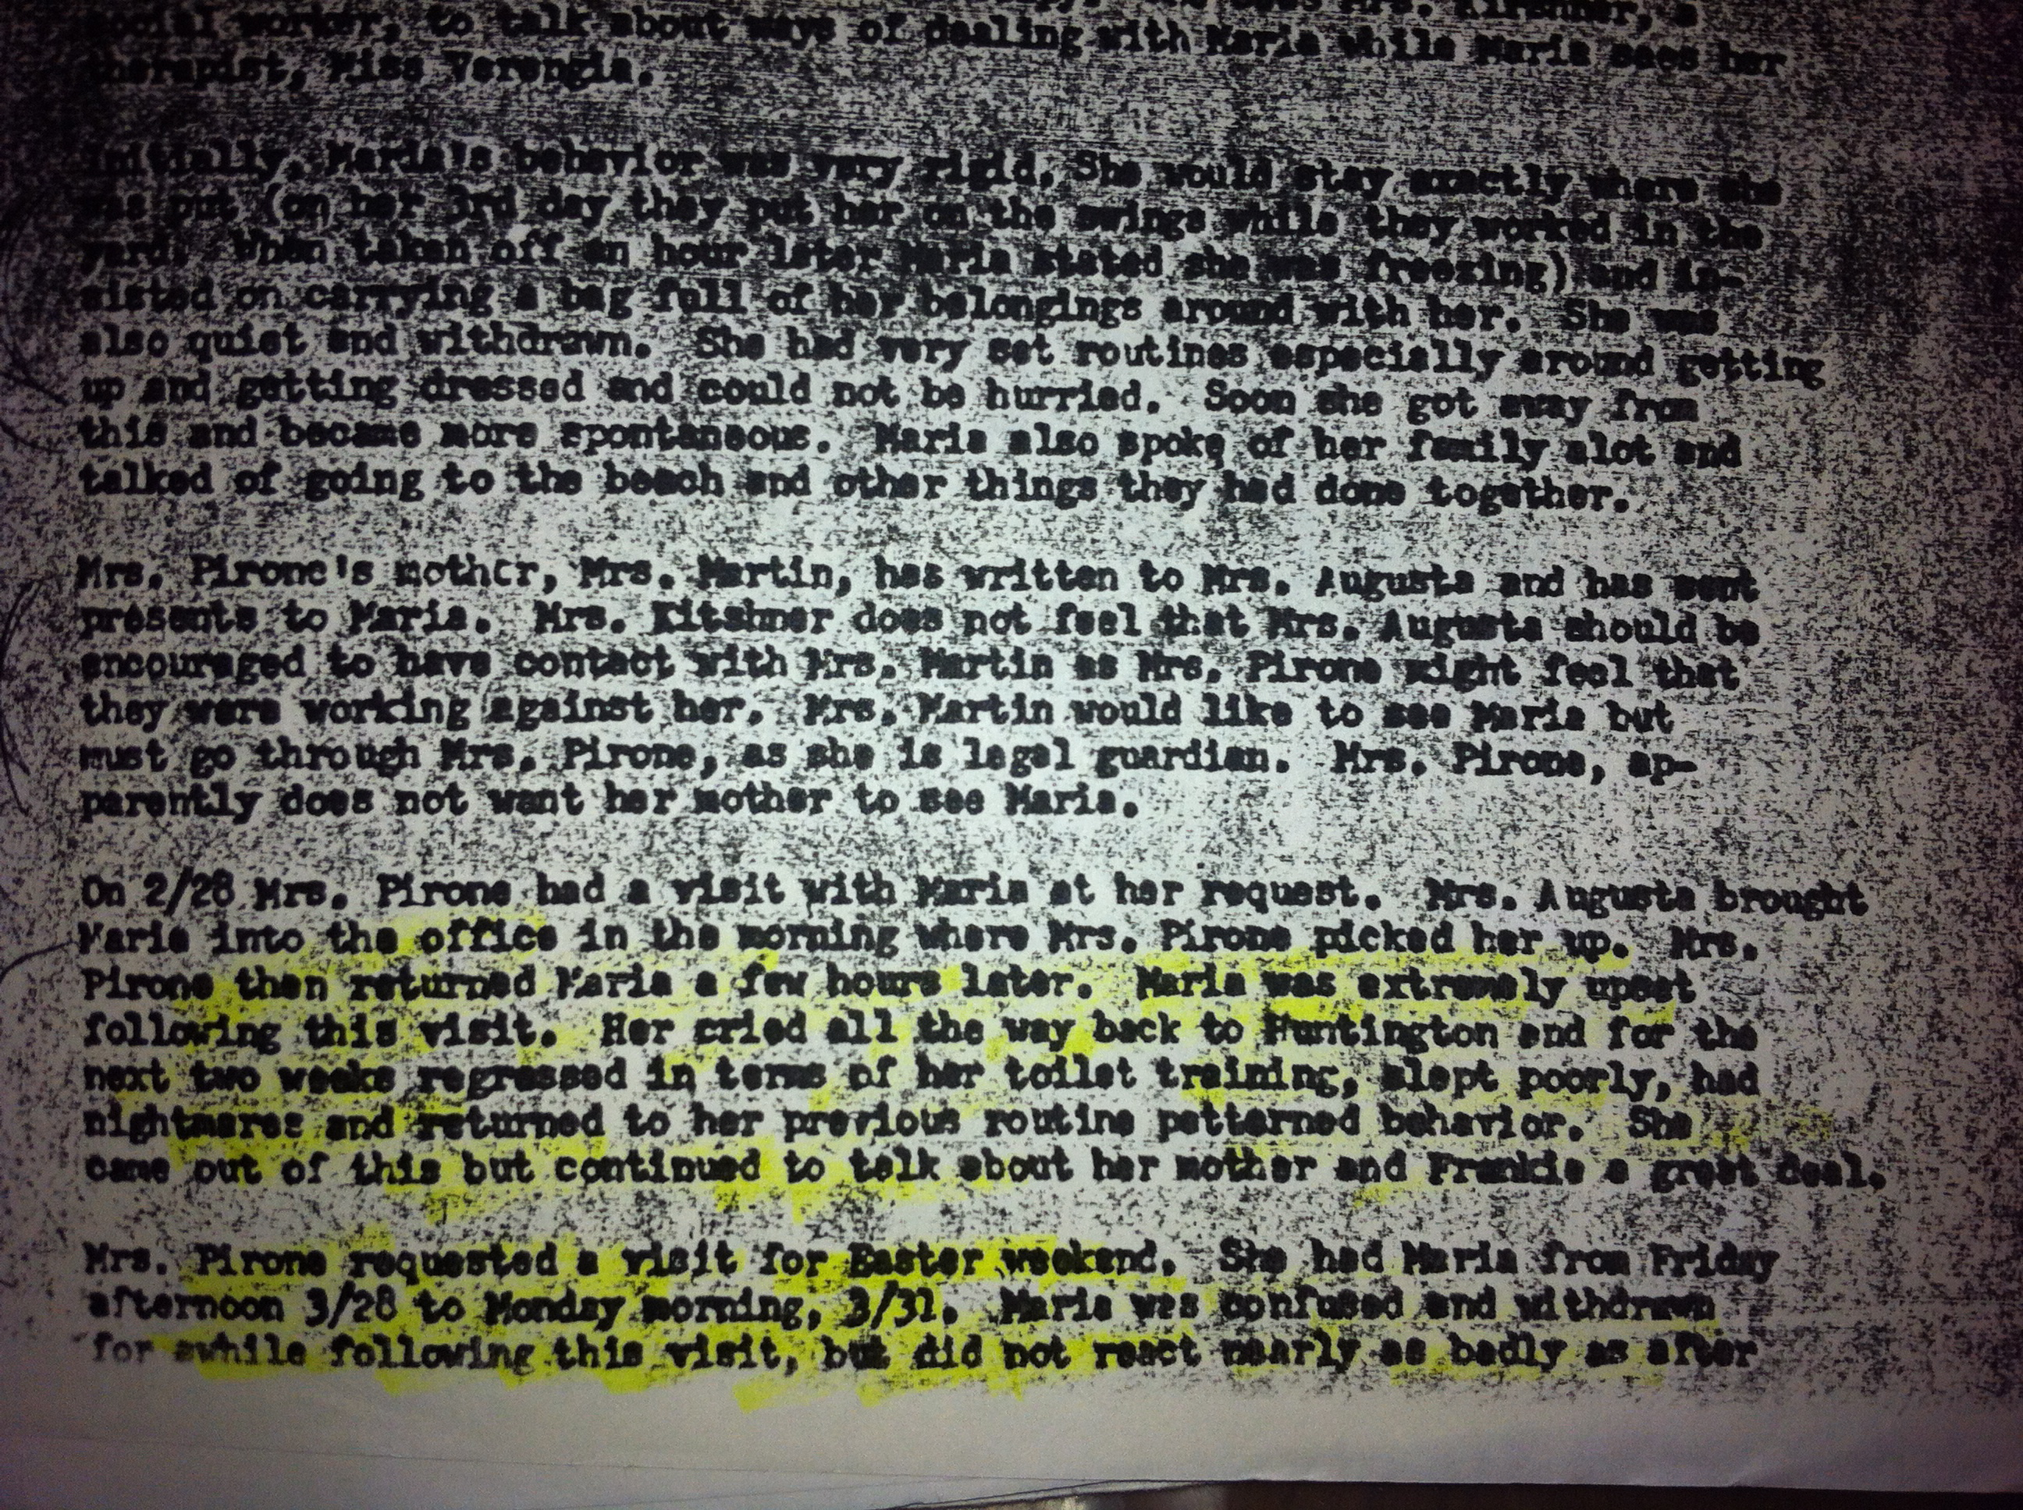
As I stated earlier my mother’s boy friend was involved in a satanic cult. I believe his father was the High priest in reality he was a geriatric pervert. Still yet High Priest is the way I remember him addressed during rituals and upon my captivity in their home basement and the farm. 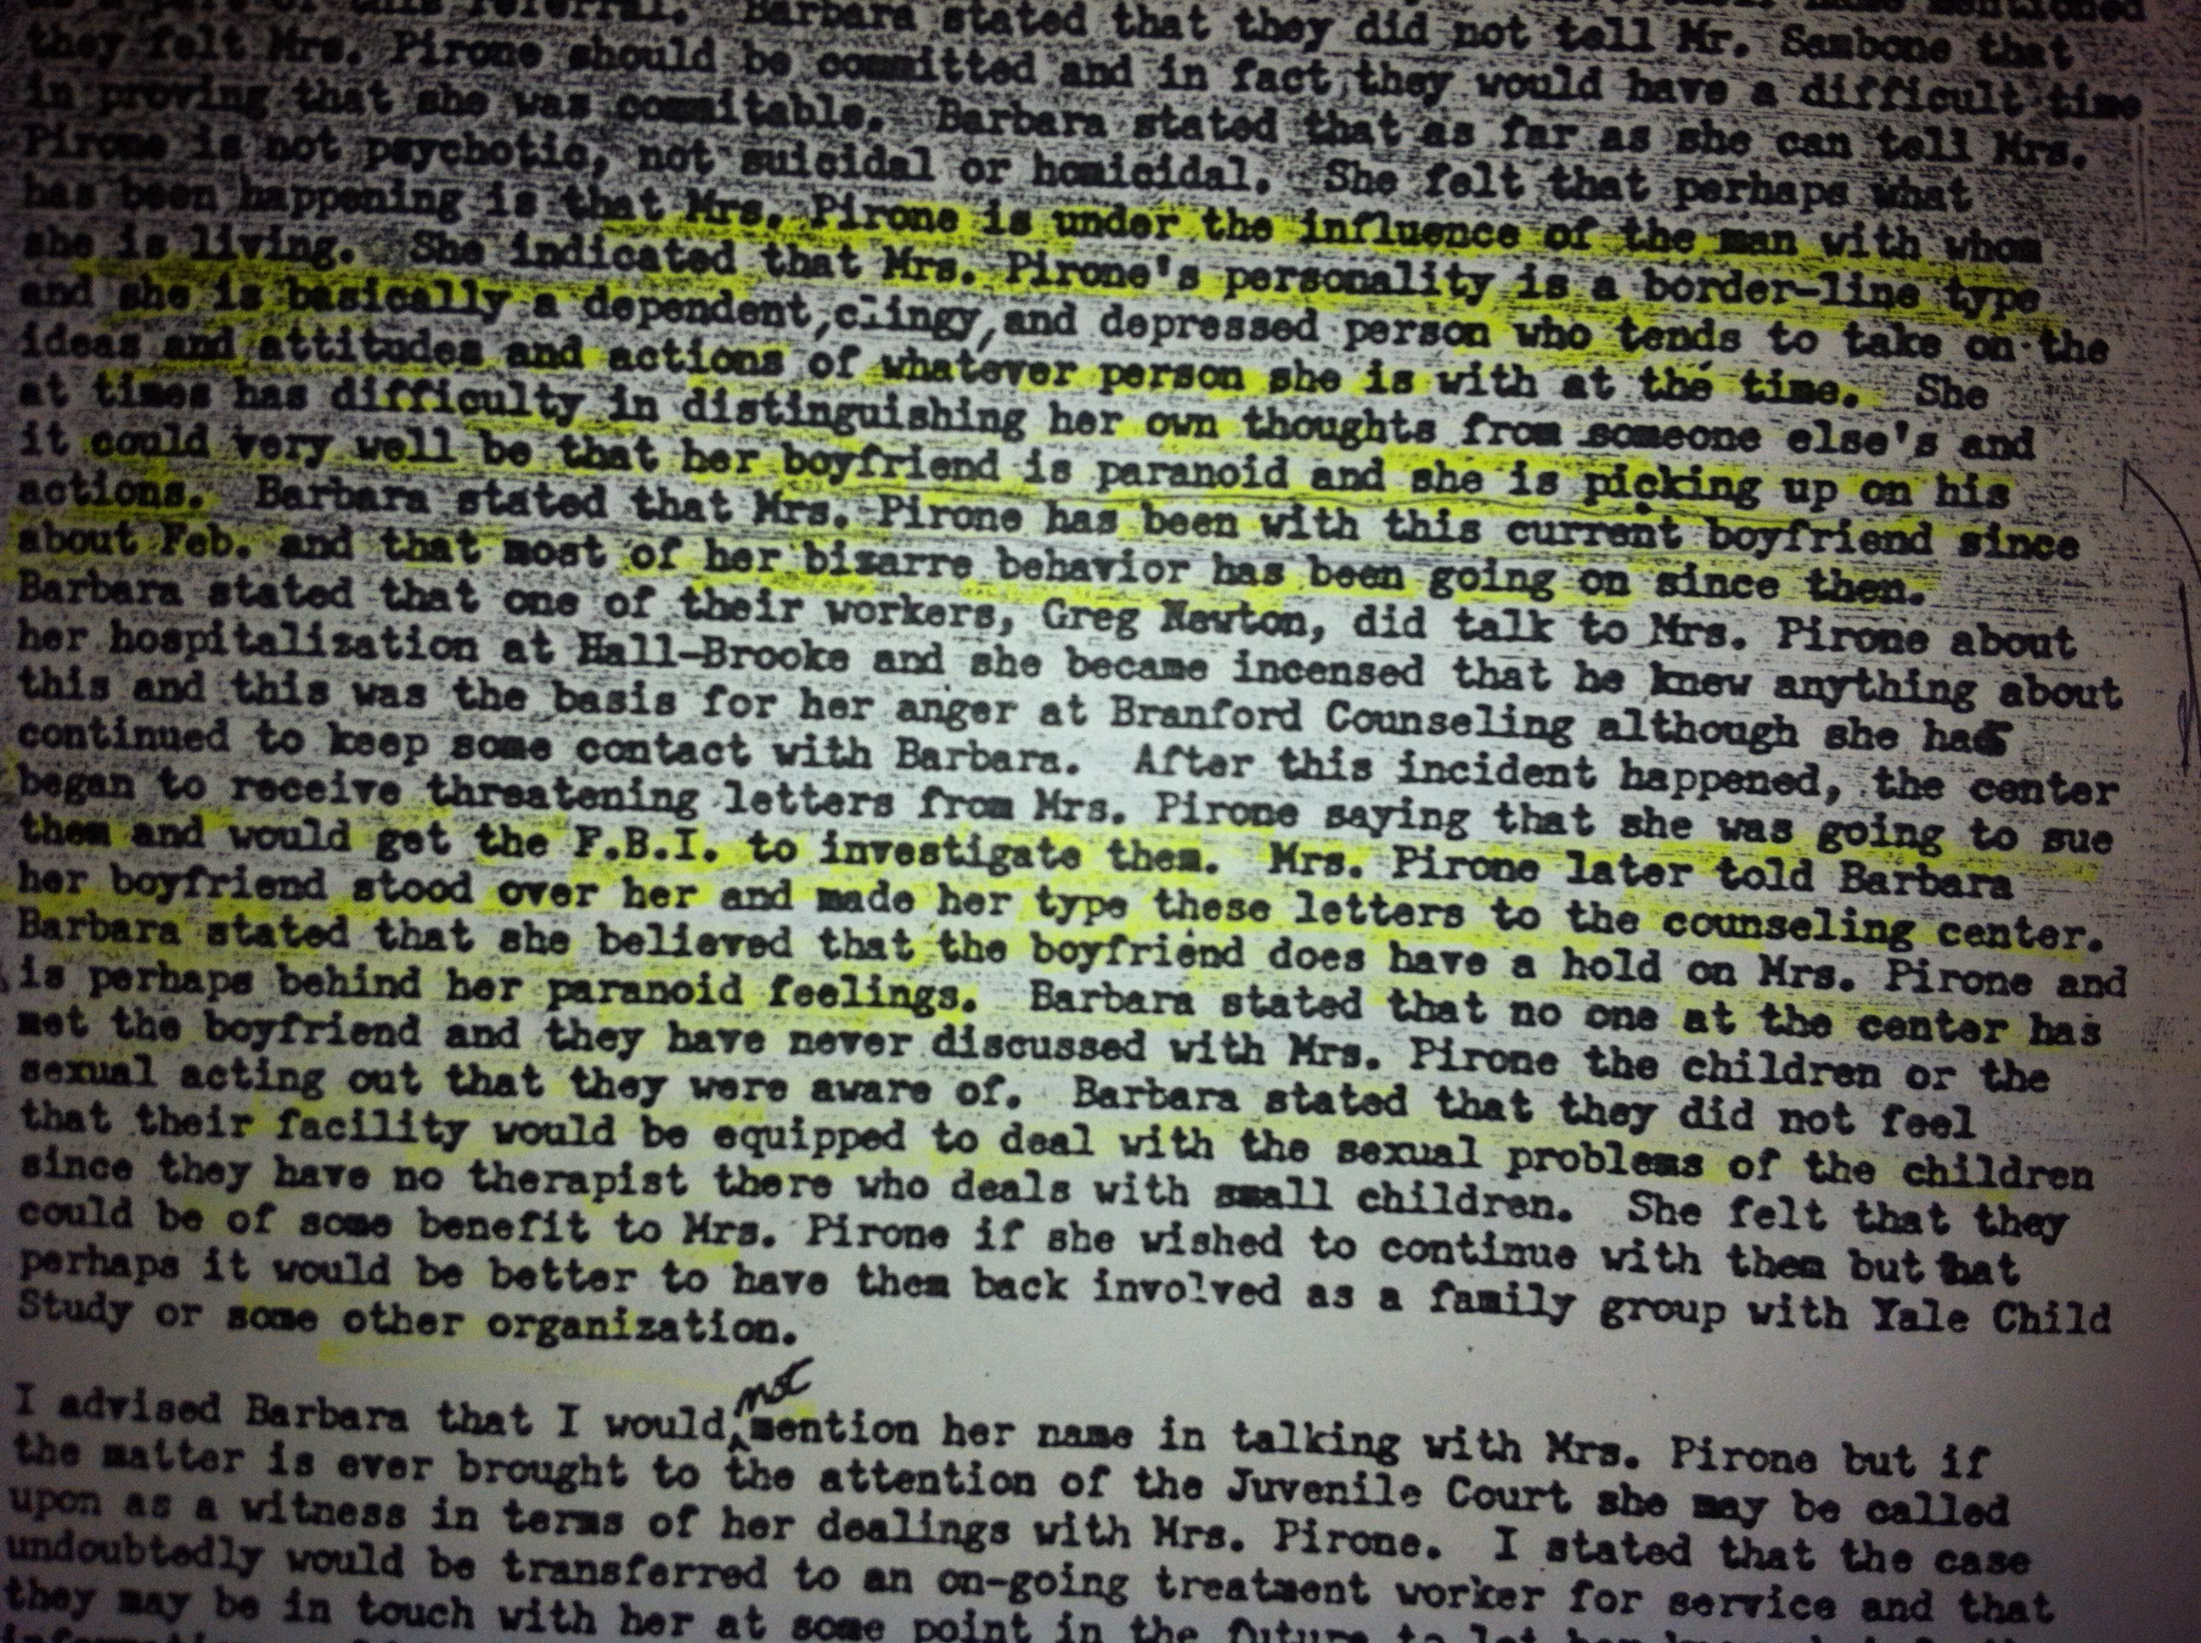
I also experienced torturous brain programming through all sorts of methods like high pitch sound whistle ear phones, hallucinating eyes drops, sexual violence, body dislocations, and was drugged.
At times it felt as though this was all done at the hands of my mothers offering.

I stayed with them on and off over the years, for holidays, birthdays and times my mother went to vacation with my brother on my father’s inheritance. 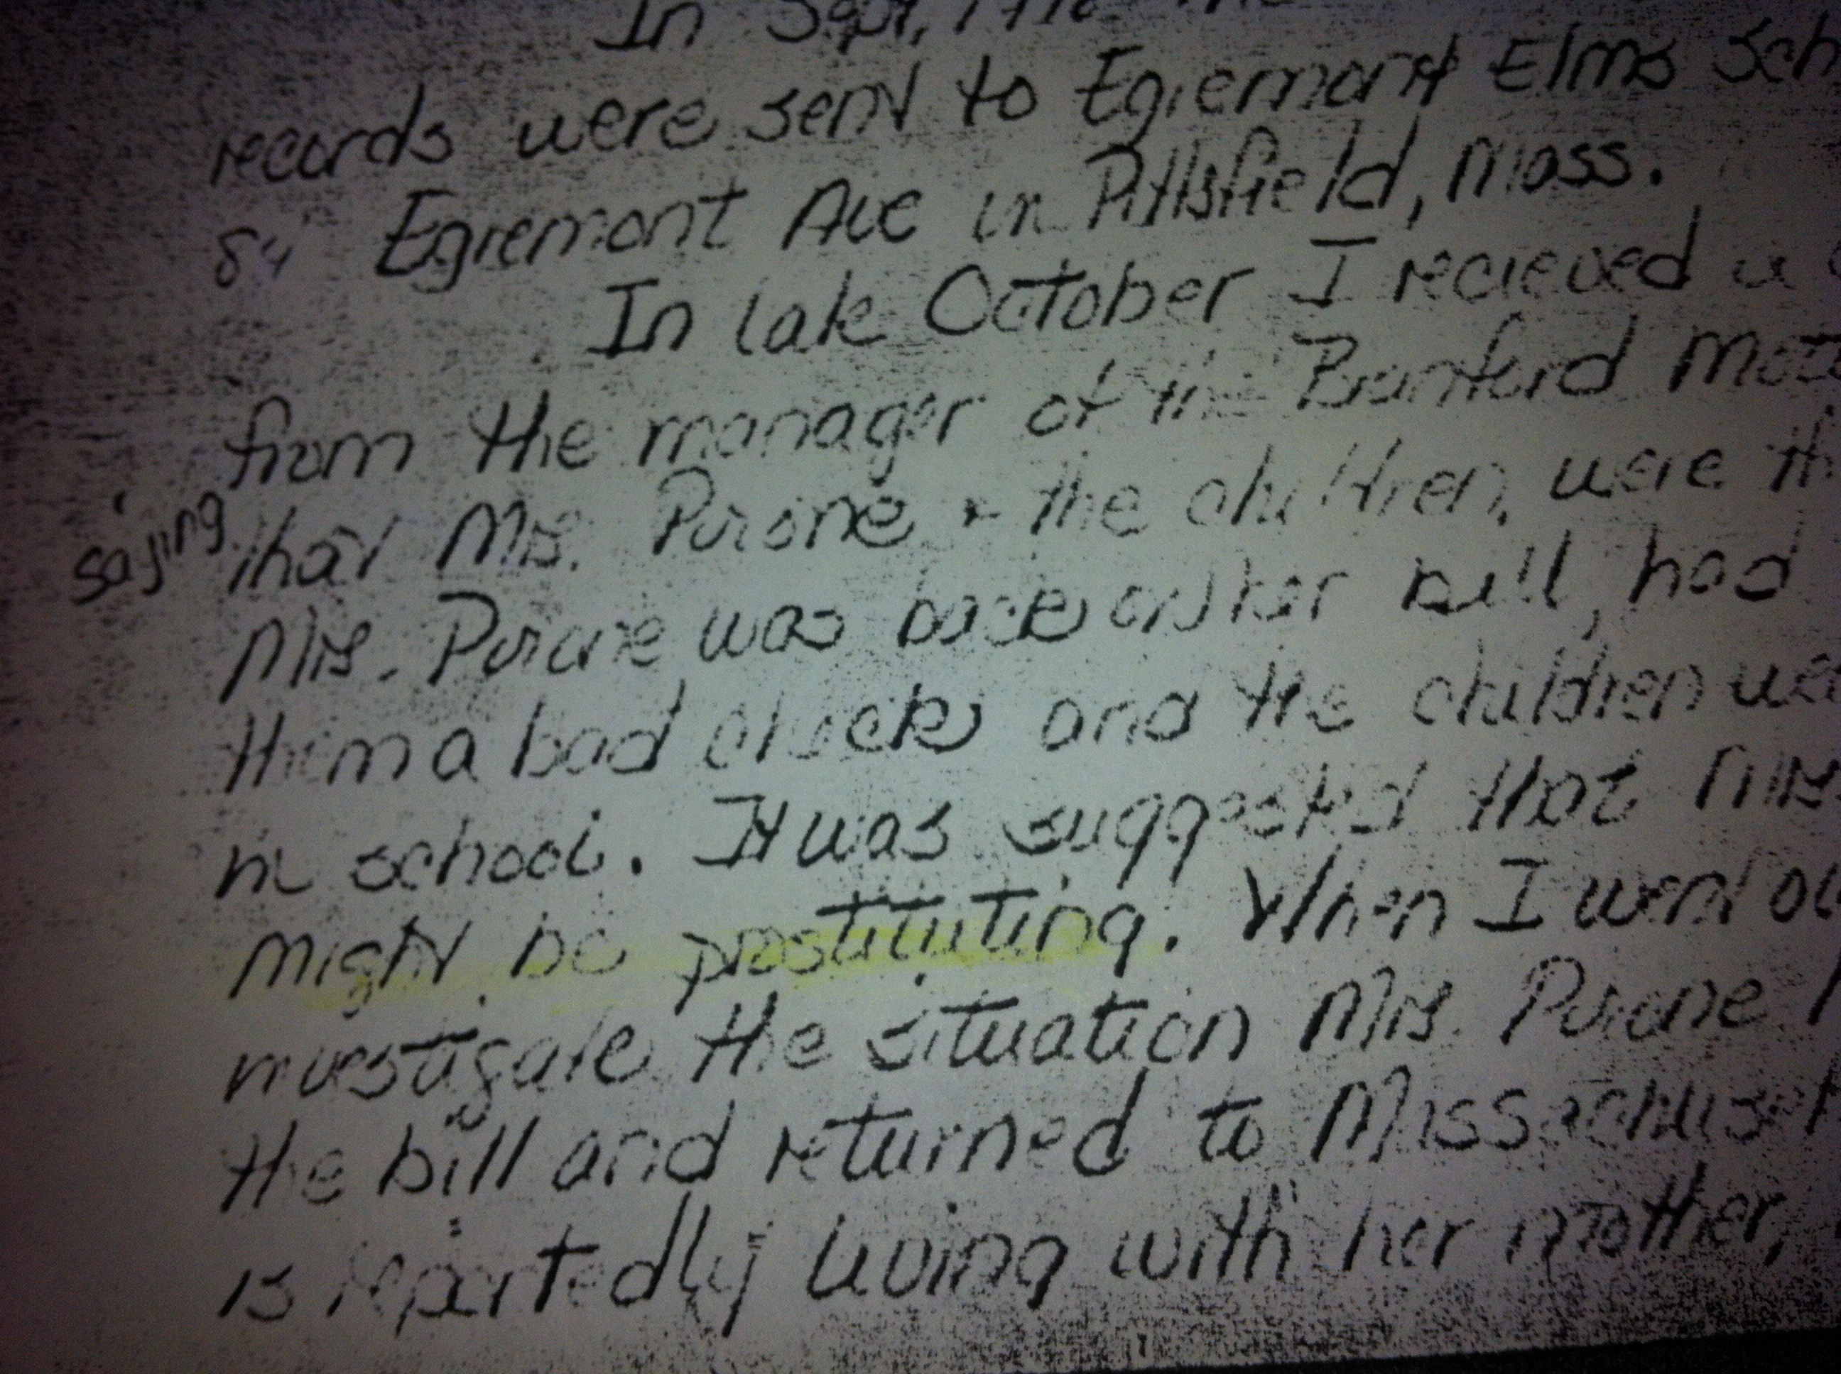In the above it is noted that my mother was possibly prostituting. But the men she was mostly involved with were coming for me. As she let them molest me and use me for child porn purposes in trade of pills. I believe all of these perpetrators were in a common circuit through the cult. 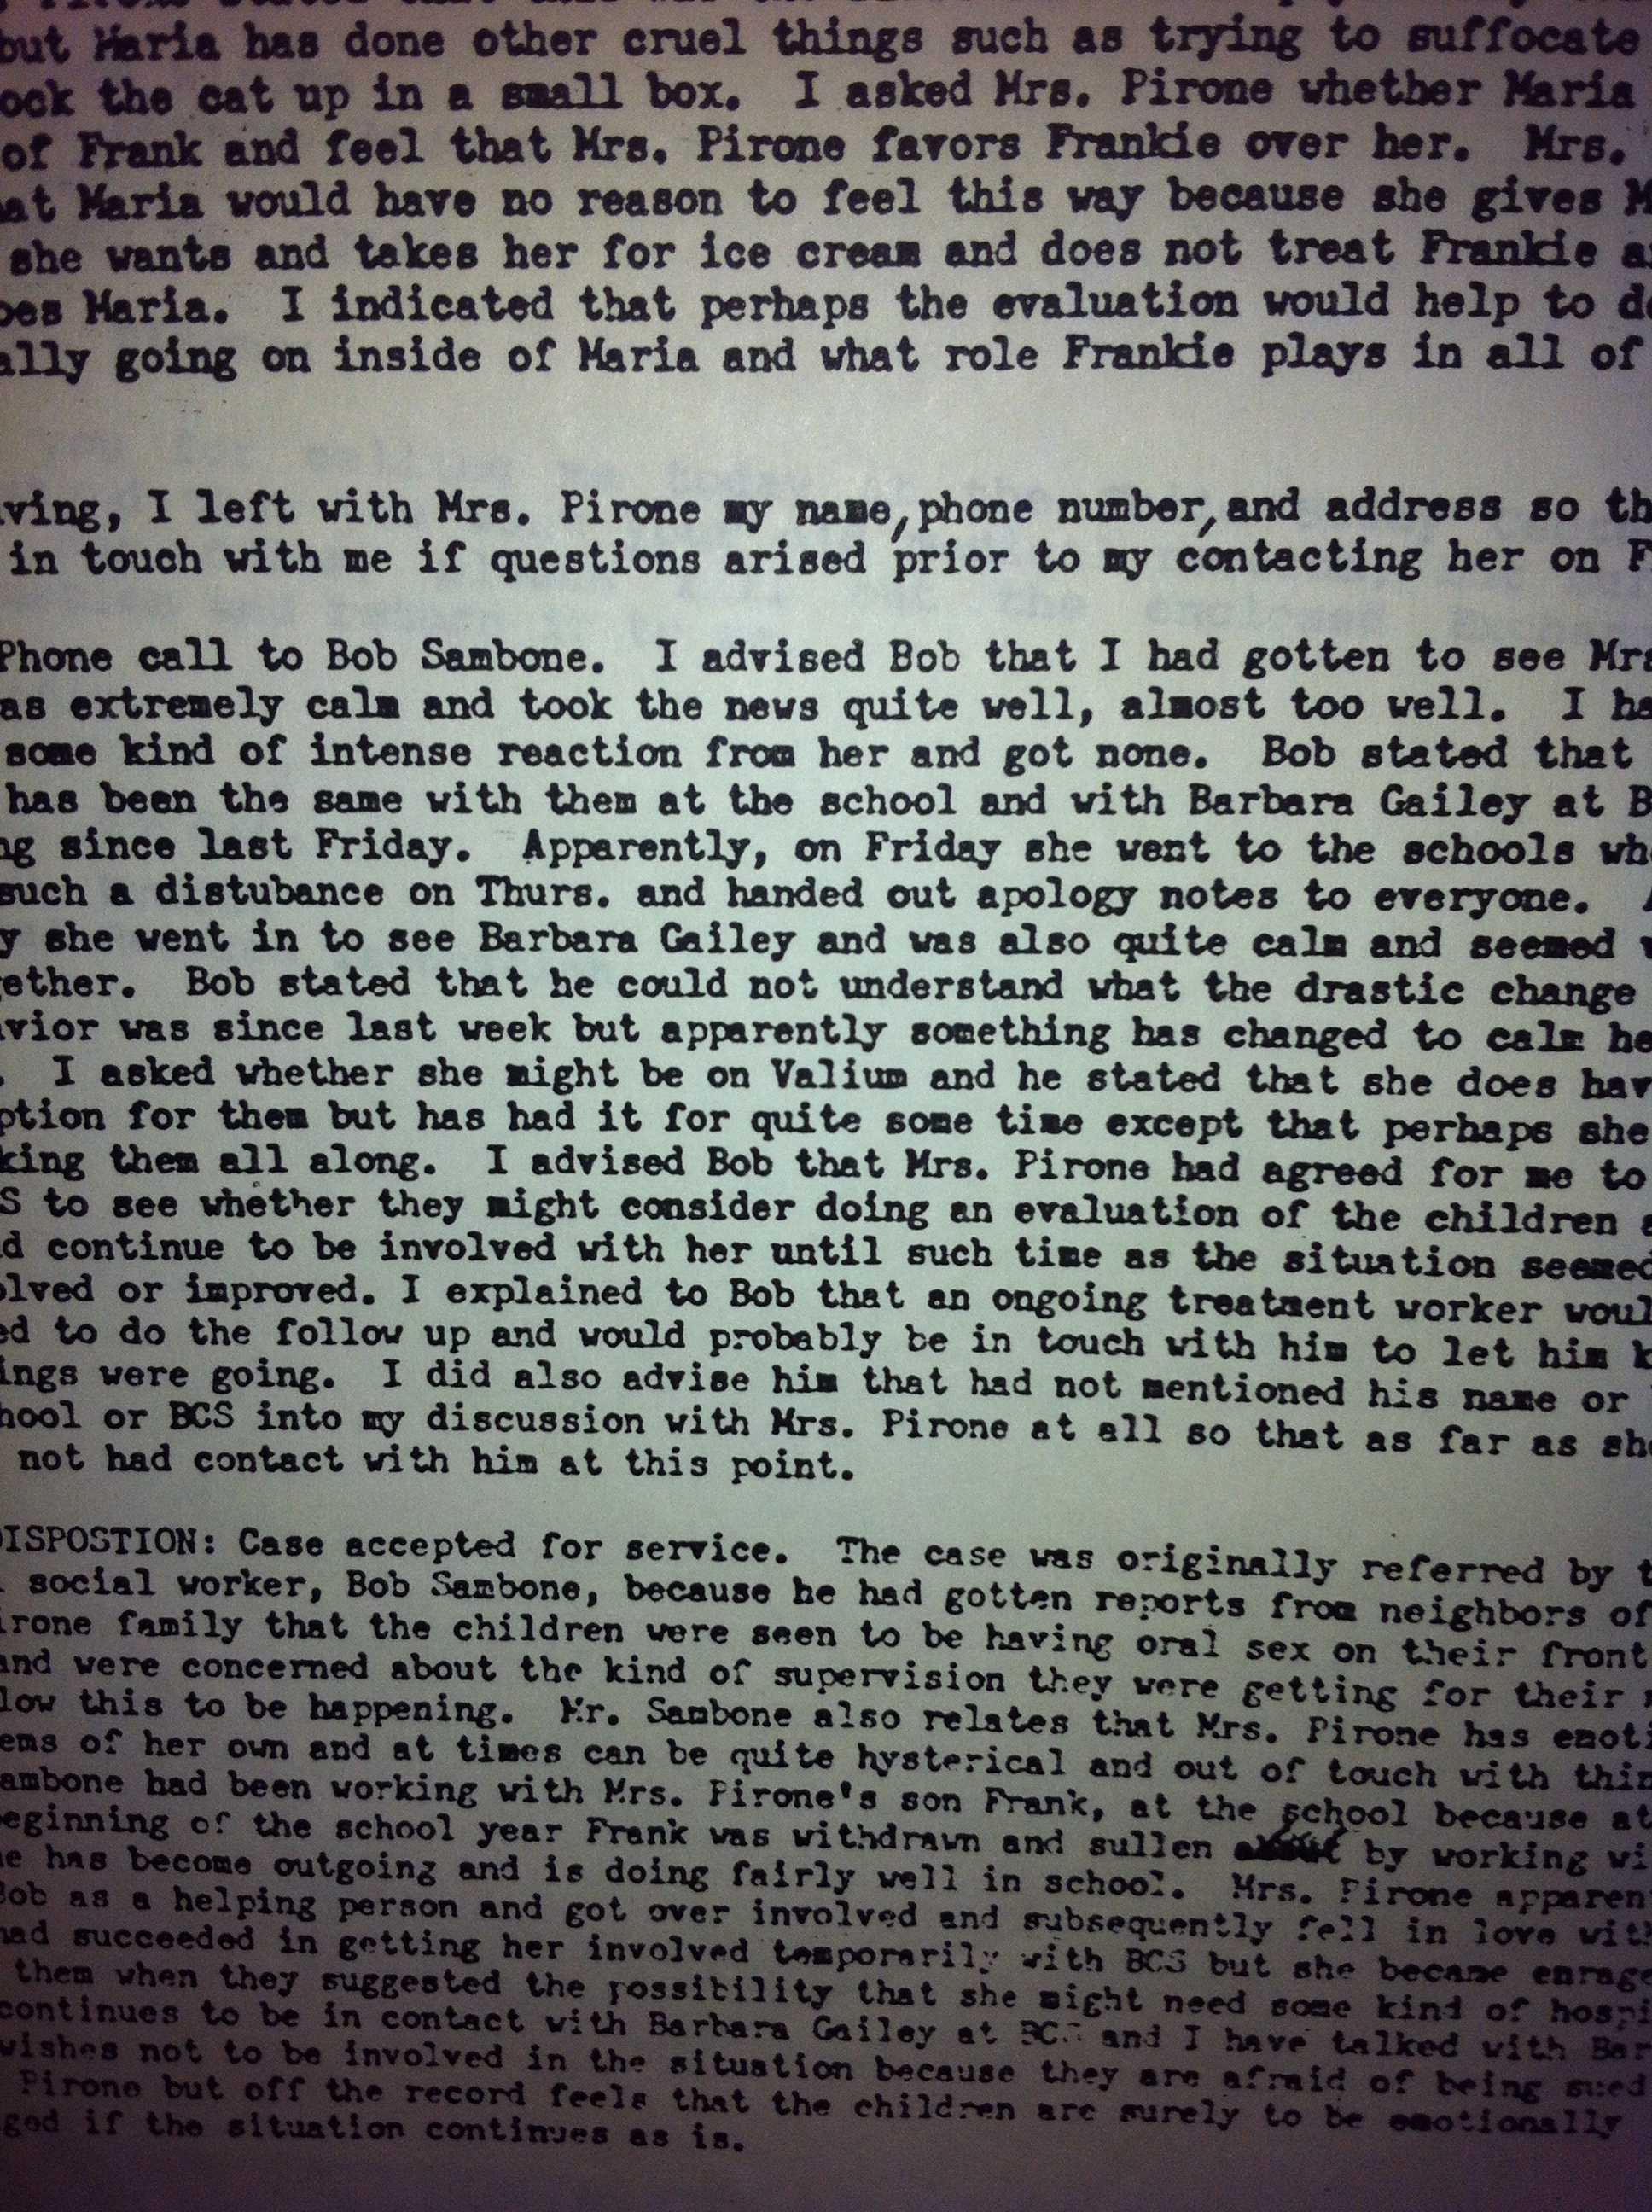

Below are possible satanic symbols I repeatedly drew as a child. In later years after in the custody of my grandmother, my mother continued to draw symbols on her neck in pen and with marker or nail polish all through out my grandmother’s house on the bottoms of all furniture.
It may also be signature related, since my mother’s boy friend made me write on my mother’s checkbook in hopes to convince my mentally ill mother that I (a young child) was cashing her checks and stealing her money.
I remember him standing over me and having me often scribble in her check book with crayons…sometime he hid her jewelry under my pillow and grab Mom pointing to it, “Can you believe it, Maria is truly Satan she is stealing your money and jewels…LOOK!”
In truth behind her back he would forge her signature and steal from her accounts, while I suffered punishments. 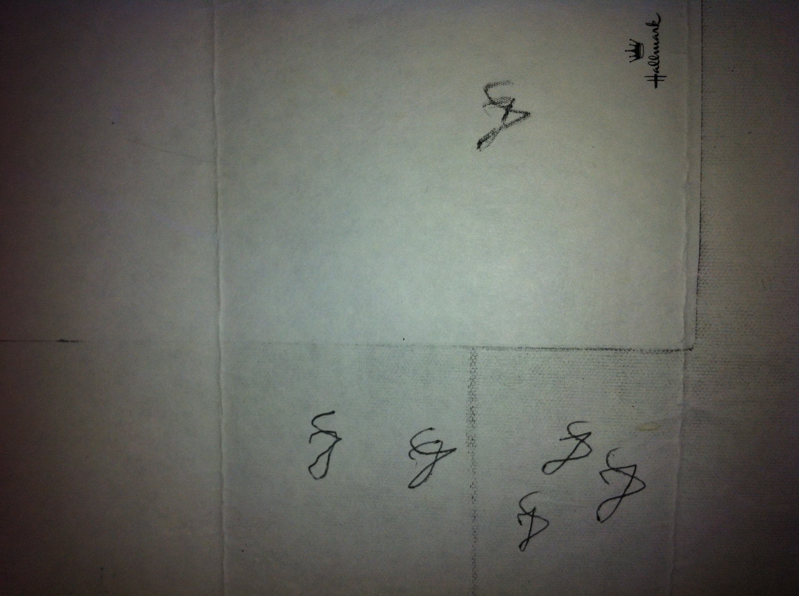
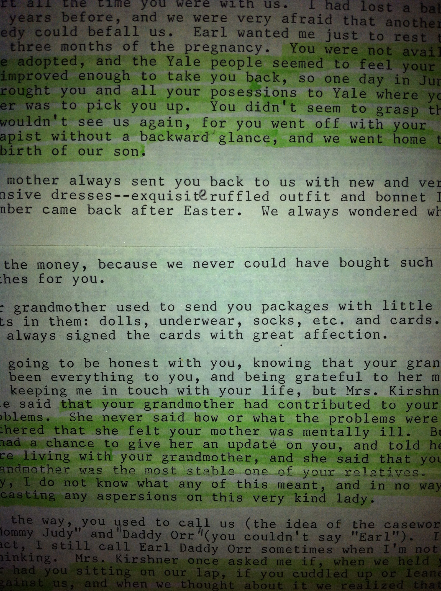
For a short time period of 6 months I did have some foster care around age 4. (good people).
I received this letter in the mid 1990’s when I reached out to these foster parents to get information about the retrieval of my memories I had repressed for 20 years.

My memories came in flashes for the first time when I was in early 20’s. I had a kind boyfriend and his care made me safe enough to start feeling who I really was inside.
The flash backs and body memories of pain/or panic began during sexual intercourse with him. I had been sexually acting out years before this…but was numb, no orgasm no pleasure no nothing...no matter what kind of sex nor with whom. But in the safety of my boyfriends care for me I opened. His face seemed to shape shift into my brothers. I would break into tears…more and more memories escalated from that point on.
I felt nuts, could not breathe, even a simple cashier in a store could put me in a spin if they looked like someone from my past.

This is when I chose to take therapy and healing seriously. It was a challenge to find a therapist who would work with me, as I wanted to be un-medicated. Pills scared me too much…reminding me of mom.

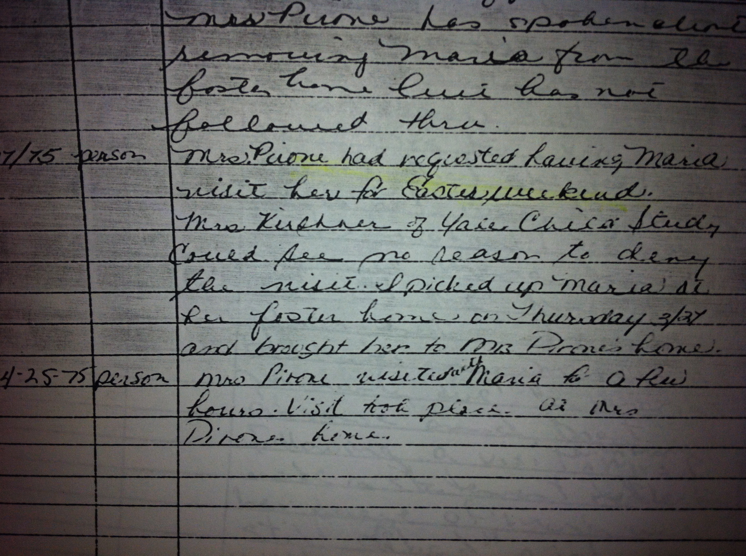Easter was a time I was sent to the cult for rituals.
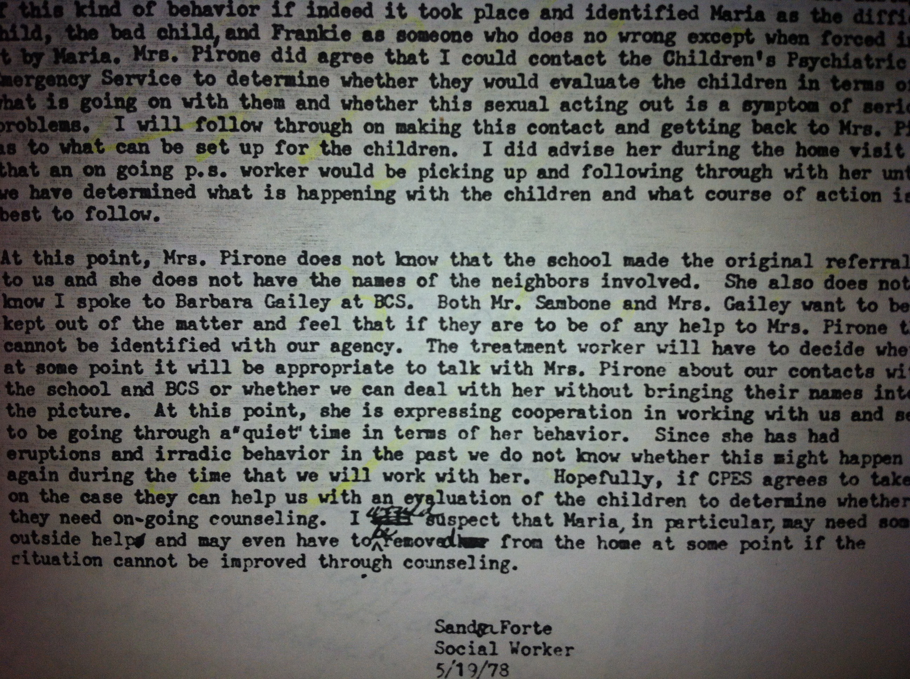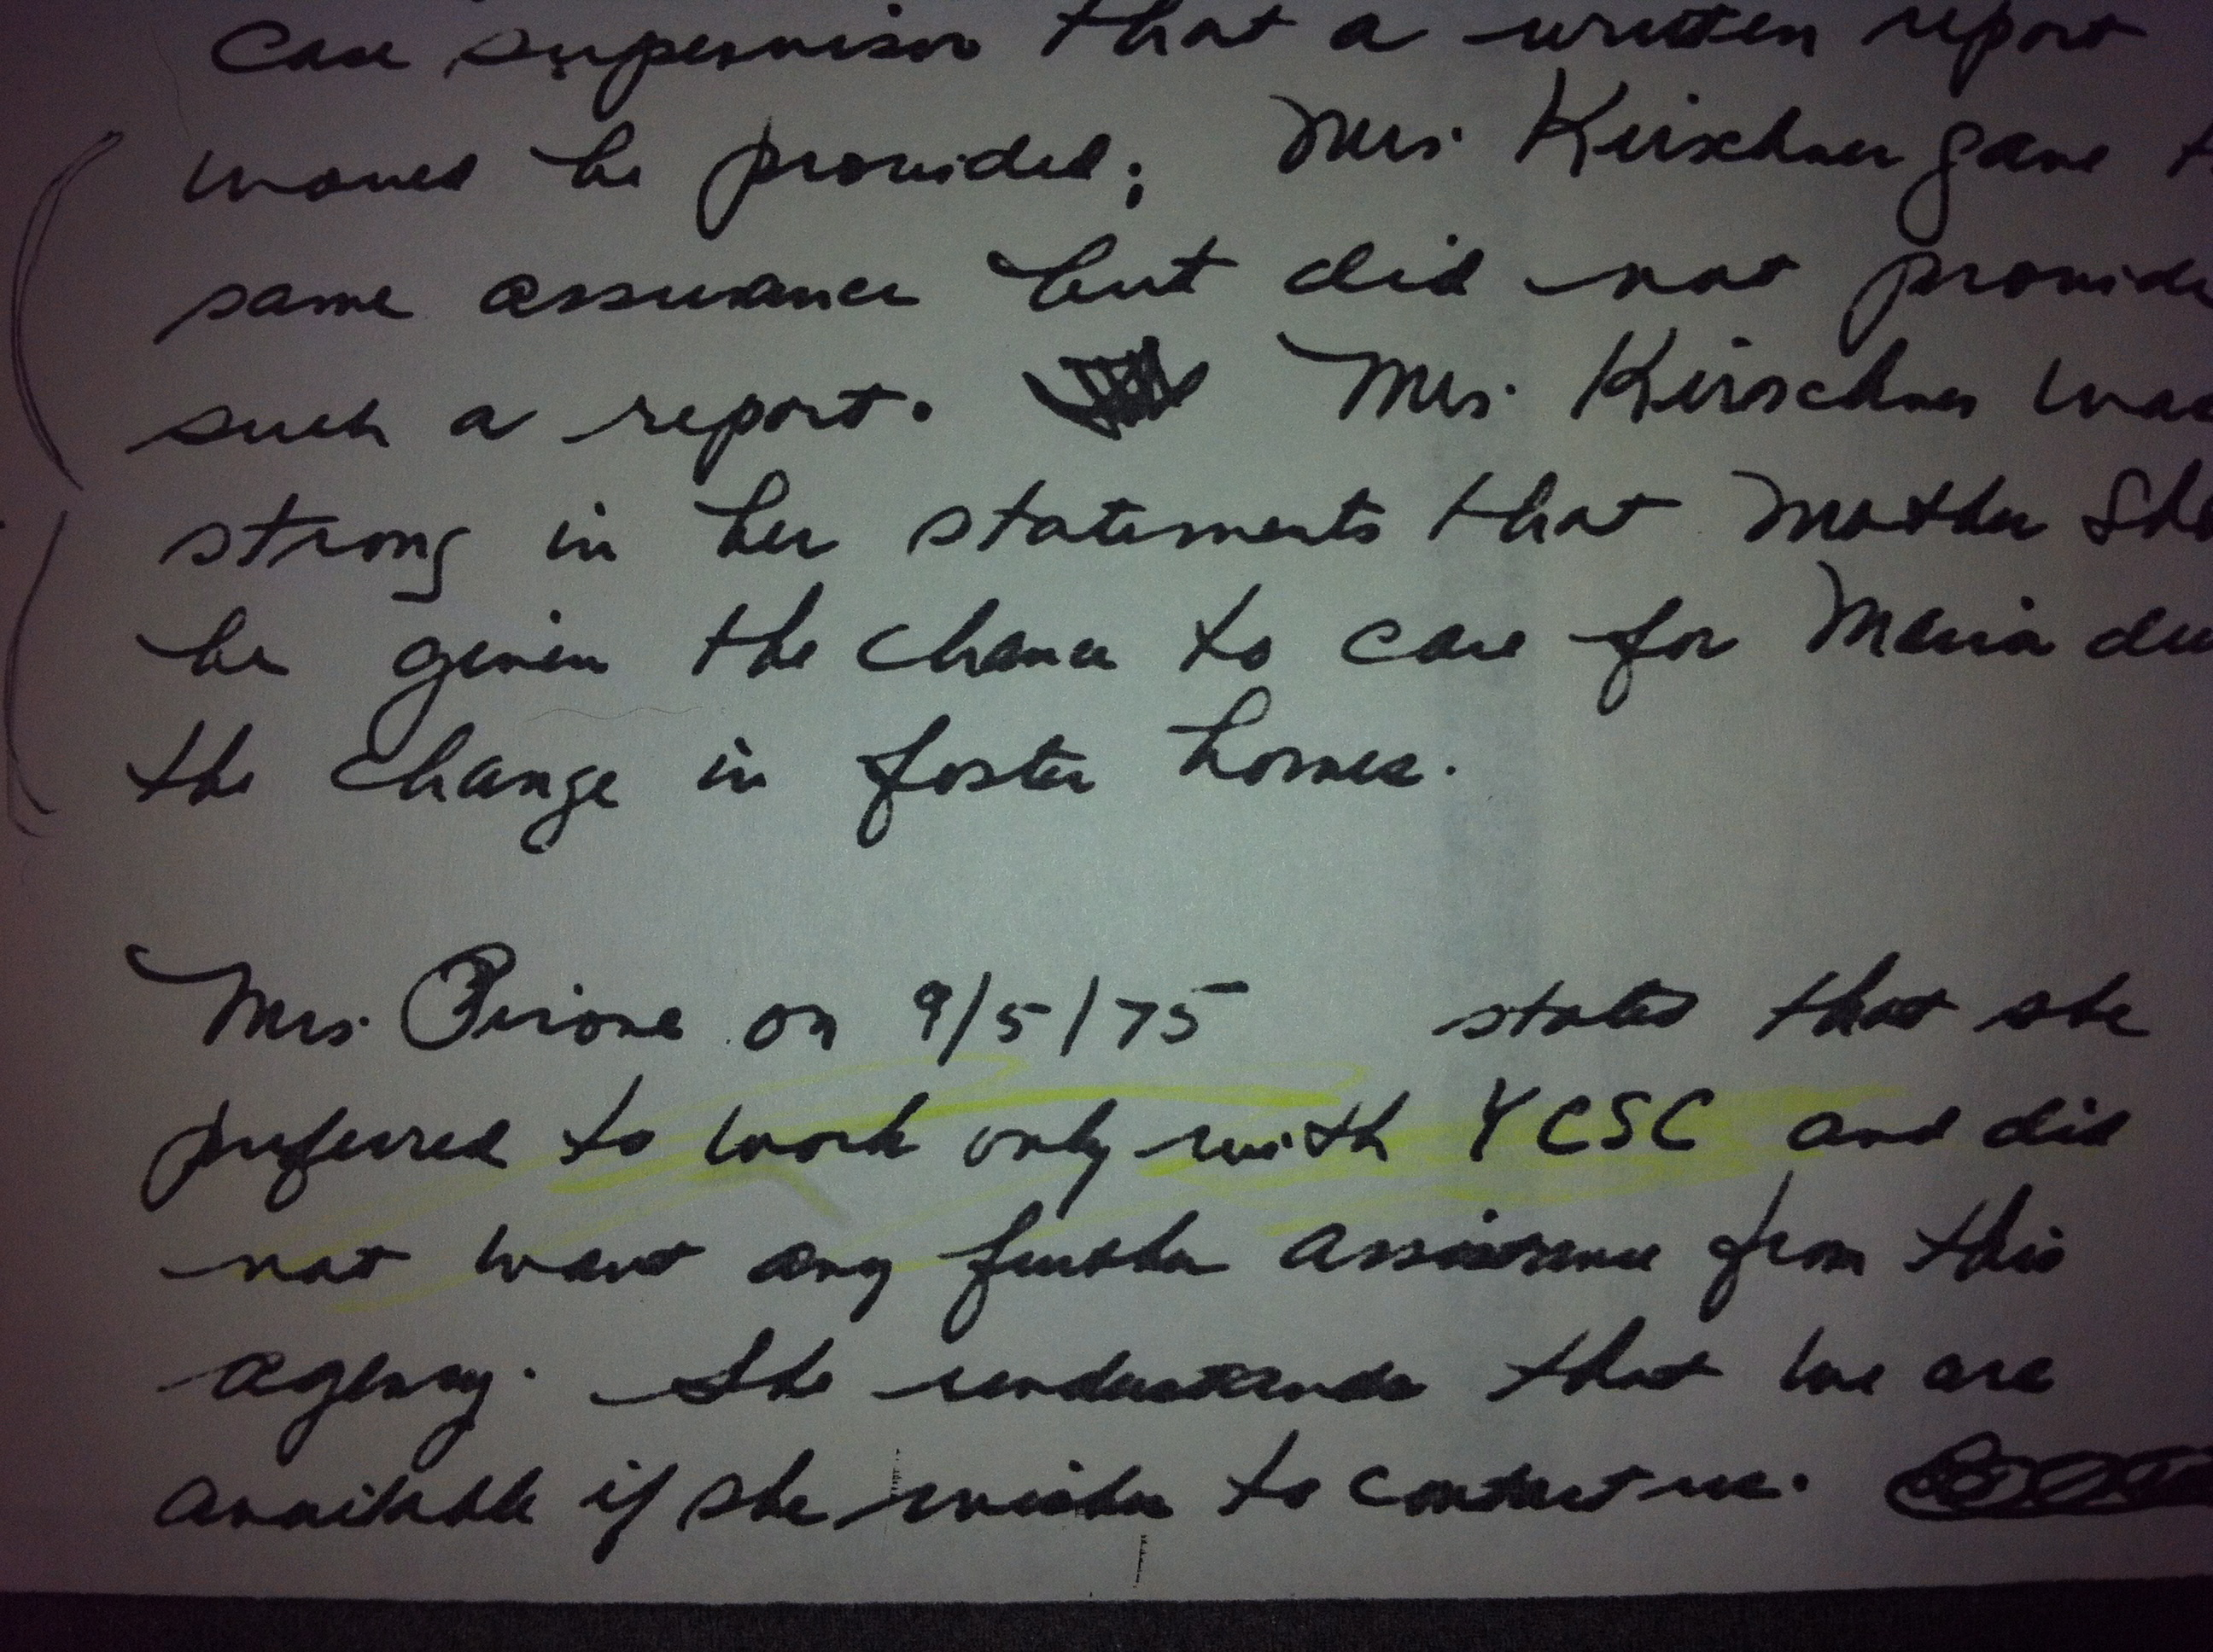

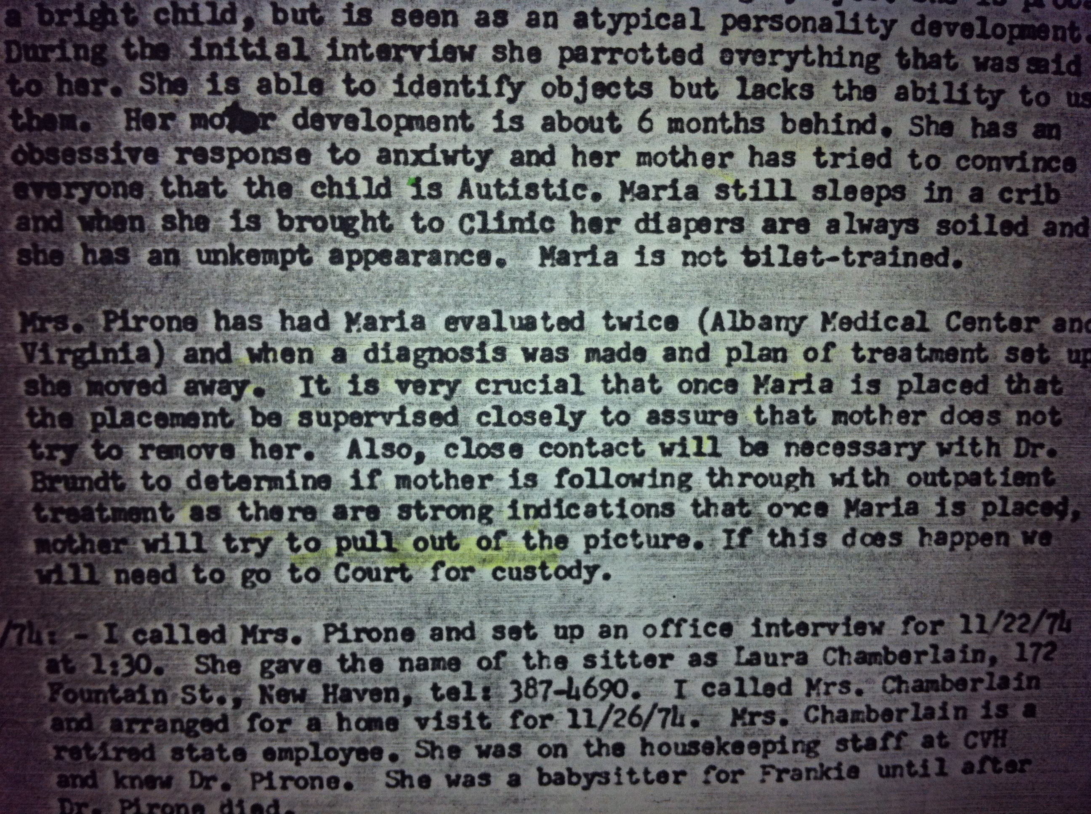I do believe my Mother’s paranoia let her to act erratically in regards to putting me up for adoption. In retrospect the cult must have told her not give me up, or they will kill her and her soul would be sacrificed to give me further power. 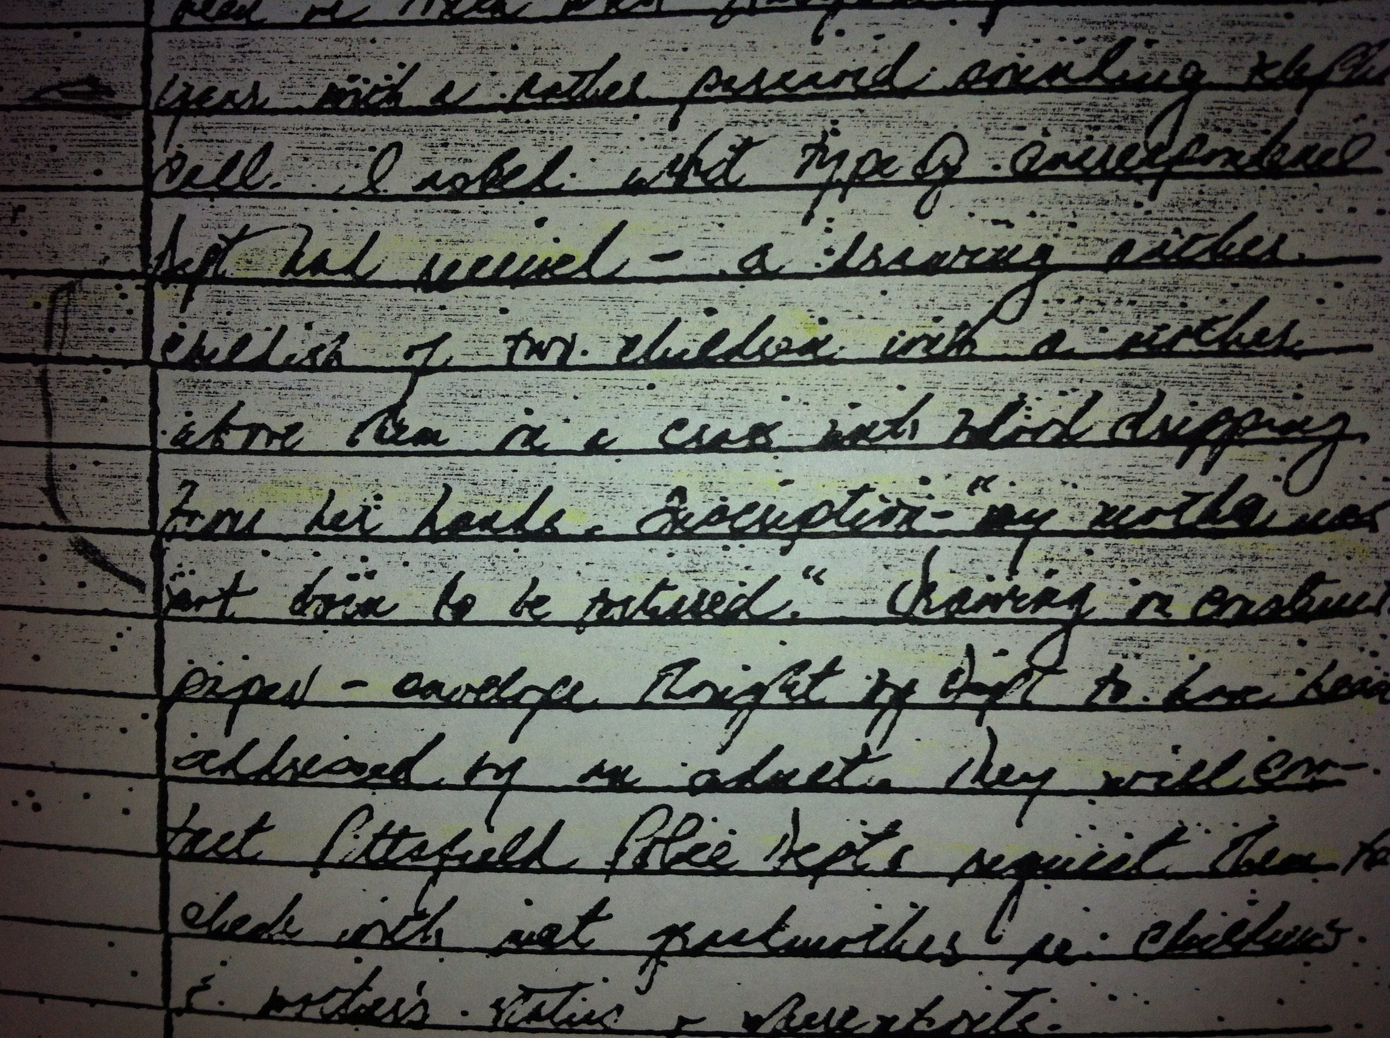 This was in a police report: “A drawing of two children with a mother, above them on a cross with blood dripping from her hands. My mother was not born to be tortured.” I assume my mother’s boy friend must have sent it as a threat? It clearly describes what would actually take place in similar satanic rituals.

There are many rituals and the affects of programming mind control can last decades:
Up into my 40’s it was a challenge to create a sustainable real relationship with a man who loved me and I loved back and progress into marriage.
The cult told me I could never marry a man other then Satan or they would kill him. Yet, after I turned age forty I would be useless to the cult as a woman. At age 38 I had these memories emerge since my dating life could never evolve into a potential marriage. I felt a block about marriage...something about it seemed deadly and I never new why. I always feared my husband would be killed. As a child the cult created a mock wedding.
In this ritual wedding I was forced to become Satan’s bride. Satan was my mother’s boy friend’s father dressed in robes and often wearing a cow bones mask in rituals that he tied to his head with bandanas.

How twisted is this…a geriatric pervert in costume marrying a 5 year old girl covered in dusty lace doily cloth as a wedding dress. They drugged me up good for that ceremony.

My trusted therapist helped me with a sort of whimsical annulment to release this program. I pictured a powerful courtroom and signed legal documents giving/granting me the Annulment away from Satan. PHEW!!!
This cleared me on a somatic and psychology level that prior to the annulment prevented me from feeling safe to be loved by a man I could marry.
Now after age 40 I am in a loving relationship…with the possibility of us in marriage. He is safe, strong, handsome, sane, and loving with me.

Poem 1, 2011

Blood has rested at the edge of my teeth for decades and my claws have cramped from digging at eternity. I’ve reached to far places that have lights for words.
Now I neither wait nor rush, I dwell in this UN fragmented me. A place so expansive that it is possible to know what you think and feel. Gravity describes me as 115 lbs but I know I am as heavy as eternity.
©maria pirone

Poem 2, 2012

Out of me a garden has grown. Multiple shades of green-scents of earths sweetness-soft petals and firm roots to rest with, admire explore, and tend.
©maria pirone

Poem 3, 2013

VACATION update: Mom
I had a break down today-horrid cramps and the reality of my moms death last spring. I have not had space to grieve at ALL since the news came. Life went by fast and I filled myself with making Stephen my focus and finding my self out of focus in long run. I am lost today -can not write well-nor think! The island can be a very painful place -a mirror showing all the years wasted in fears. Fears that still chase and pick in my skull. I am cleansing even though others may think I lay in the sun laughing it up. Not so- hear I cry - so I can laugh when I come home. ©maria pirone

A vision to come true:
My experience would make a fantastic major motion picture!!!!!! If there are any interested producers and ghostwriters out there – Let’s make this happen!!!!!

To you all!

I appreciate your courage in reading my story.
Be blessed and in peace.

